**ERP**

E – Enterprise (a big company)

R – Resource or Departments

P – Planning(utilization of resources)

Is a continuous activity in each organization to make sure that everything is going / working properly and efficiently.

NON-ERP: Each dept maintain their data in separate db/locally maintained and maintain separate S/W for their business process. Not able to get data from other dept as fast, we will need to wait until some person provided the requested data.

ERP is an integrated software which integrates various functions/modules of an organization. Through ERP each dept interacts with another dept/get data from another dept. They maintain all their data in the same DB.

For eg, if new order came, we need to check whether order is there or not. If not there na, we need ask the production to make the prod -> then if no raw mat is there -> then purchase dept need to purchase raw mat from vendors. Since it is integrated in some products like SAP , we can get info / data about the requirement and get it done.

Business process/Cycle :

Minimum dept in each organization:

Eg:

Product manufacuture company :

Purchase(raw material purchase from vendor) -> Warehouse/INVENTORY (store the purchased material) -> Production (Finished prod -manufacture/produce the product and give it to Warehouse dept) -> Sales & distribution(warehouse dept info passed to this dept and marketing the prod, quotation of an prod and get the cust-info) -> Shipping (deliver the prod to cust address) ->Finance(collect money from cust and pay money to vendor/suppliers)

HR -> recruit employees for each dept and salary related details are discussed here and so on.

Sales dept(order info) ->

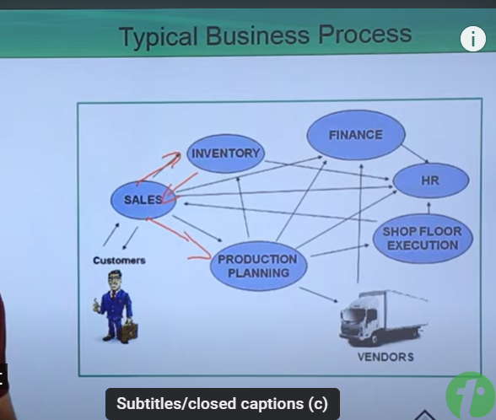

Purchase Department has to plan

* What to purchase?
* When to purchase?
* How much to purchase?
* From where to purchase?

**Conclusion:**

1. ERP is directly proportional to quality of Output
2. Quality of output is directly proportional to the shape of the organization
3. Shape of the organization is directly proportional to the Earnings of the company.

Each Enterprise / Organization has to plan their Resources / Departments as effectively as possible.

ERP – How planning the resources of an Enterprise can be done?

* Manually
  1. Time Consuming
  2. Not Error Free
  3. Redundancy / Duplication of Data

When the scope of the organization is small, it can be followed / recommended

* Automation
  1. Less Time Consuming
  2. Error Free
  3. No redundancy / Duplication of Data

When the scope of the organization is big, it can be followed / recommended

**ERP has to be automated, what is the suitable S/W solutions?**

* ERP Softwares / Packages / Products / Solutions
  1. Which are READY to USE.
  2. Effective communication.
  3. All in One – Same solution/data can be used for the entire organization.
  4. Same database has been maintained for all dept.

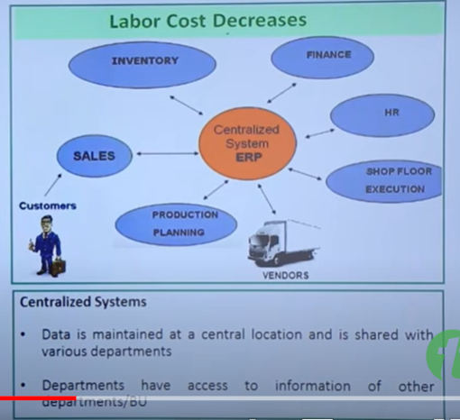

* Non-ERP Solutions:

**NON-ERP :** Each dept maintain their data in separate db/locally maintained and maintain separate S/W for their business process. Not able to get data from other dept as fast, we will need to wait until some person provided the requested data.

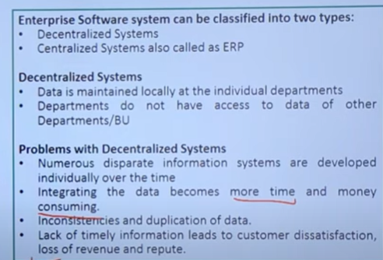

* 1. Which are not ready to use: the solutions have to be developed from the Scratch for all the departments so that the organization has to wait for long time to use the solution.
  2. Not All in One – not same solution can be used for the entire organization: the flow of information across all the departments of the organization is not default / automated and it may be either manual or interface have to be developed across all departments to let them access the required data.
  3. Lack of communication between departments/functions. Decentralized system.

**Uses of ERP:**

* It is the **centralized system** to provide the strong integration between the different business or functional areas.
* Customer Satisfaction.
* It provides the correct information on time to take the business decisions.
* Better Resource Utilization.
* On Time Delivery.
* Higher Management achieves their goals and targets using proper implementation of ERP .
* Better Business Plan.

**Different ERP Products available in market?**

* SAP
* Oracle
* Microsoft Dynamics
* People Soft
* Seibel etc

**Evolution of ERP:**

* In old days Manufacturing Requirement Planning (MRP – II) and Material Requirement Planning (MRP) are used before ERP is evolved.
* MRP and MRP-II doesn’t have integration between different business units.
* ERP is evolved from MRP – II
* MRP – II was evolved from MRP

ERP **<-** MRP- II **<-** MRP

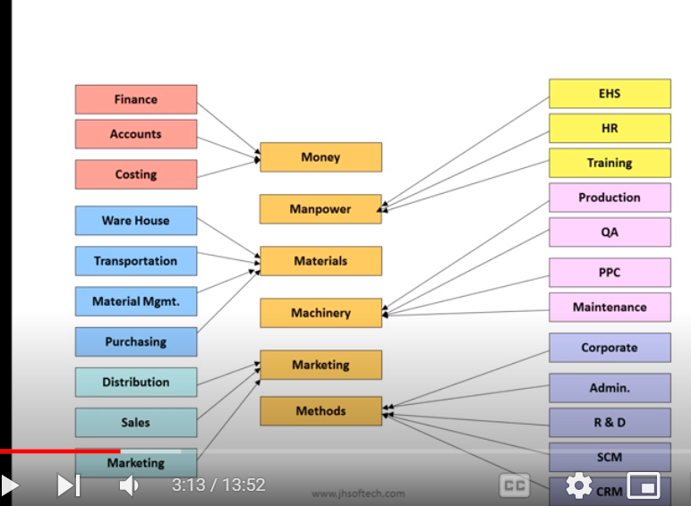

**SAP:**



S - System

A - Application

P – Products in Data processing

Sap is an ERP software.

* It’s a Germany based Company which was founded in June 1972 as “System Analysis and Program Development.”
* The first release where R/1 and R/2 which were mainframe applications.
* In 1979 SAP released SAP R/2 into the German – first integrated, enterprise-wide package.
* Towards the end of 80’s, Client Server Architecture became popular.
* SAP responded with the release of SAP R/3 in 1992.

R – Real time; 1,2,3 – x (1/2/3) tier architecture

SAP **R**/1 -> 1972: Enabled customers to get a complete view of their business with real-time processing of data across integrated modules for Materials, Procurement and Accounting.

SAP **R**/2 -> 1982: Helped customers successfully manage large global enterprises on a mainframe architecture, while retaining the integration and real-time processing capabilities of R/1. (Client-server architecture)

SAP **R**/3 -> 1992: Enabled customers to take advantage of Client Server and Internet technologies. Created a unified graphical user interface.

SAP S/4 HANA -> 2015

**Features of SAP:**

* Ready to use i.e Solution is already developed for all the departments in the form of modules.
* All in One i.e SAP is tightly integrated across all the modules / departments so that the communication / flow of the information across all the departments are default i.e the right people in the organization – can always access the right data at right time with no effort **(no delay)**.

**Difference between ERP and SAP:**

* ERP are software solutions that helps organizations to manage business process. SAP is company (multinational company) that sells ERP Software Solutions to business.
* ERP systems are more focused about organization growth, SAP takes care of both Customer and Organization.
* ERP is web-based application. SAP – provides variety of options (Cloud / On Premise / Hybrid)

**Benefits of sap over other erp systems :**

* Sap is suitable for any size of business.
* It is available for all types of industries with fewer customizing.
* ;SAP provide the industry best practice solution. I
* Sap continuously provide new version of there products
* Compare to other erp sap required shorter implementation time
* Easy to integrate with non sap systems, through various technical approach.
* It is a global product, support available all over the world
* Very good integration across different functional modules as sales, finance, purchasing

production, HR etc.

**SAP Business Suite (Service provider) :** (Like Microsoft – excel,ppt,team..) Collection of various SAP Enterprise Software that ensures optimized execution of business process / business strategies. It consists of following SAP Systems:

1. SAP CRM (Customer Relationship Management) – Records the information during sales etc.
2. SAP ERP (Enterprise Resource Planning) – Help to manage enterprise process- MM,SD.
3. SAP PLM (Product Lifecycle Managem`ent) -
4. SAP SCM (Supply Chain Management) -
5. SAP SRM (Supplier Relationship Management) – helps to manage the buying and selling the material

**SAP NetWeaver:** SAP NetWeaver is the technical foundation for many SAP Applications. It is a solution stack of SAP’s technology products. It is a technology platform to run the SAP business suits. It helps to run the application.

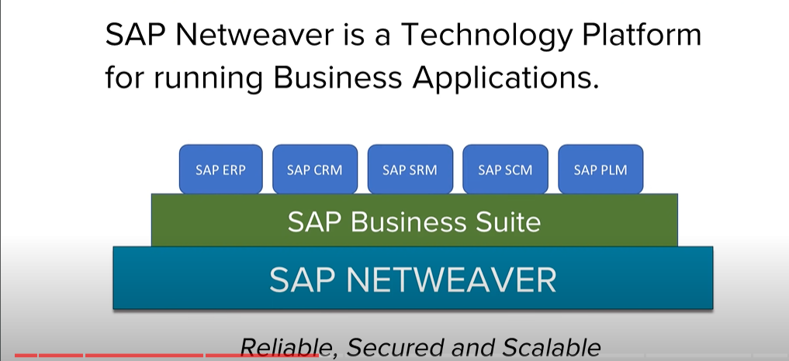

**CLIENT – SERVER ARCHITECTURE**

Client: Which can send the requests for services

Server: Which can provide the services to a group of clients / client













**3 Layers:**

* Presentation Layer
  + It is an environment from where all the requests are sent for the services.
  + Results / Outputs / Services are displayed in Presentation Layer.
* Application Layer
  + Receives the requests from Presentation Layer to get them processed.
  + It also sends back the services to the Presentation layer.
* Database Layer
  + It is a central repository of the data.
  + It provides the data base services to client / group of clients

**Different Architectures of SAP**

**R/1 - Single Tier Architecture:** In this architecture, all the three layers will be there in the same system.



**R/2 – Two Tier Architecture/Client-server architecture:** In this architecture, there is a separate system for Presentation Layer and one system for Application and Database Layer.



It is also know as client server architecture, in this case all use users are directly connected

to same server from there system, the problem in 2 tier concept was if the number of users

are more, then system was working very slow.

**R/3 – Three Tier Architecture:** In this architecture, separate system will exist for separate layers.

In this case, one layer added as application server, so after fetching data from data base all business logic performed on application layer, we can use multiple application layer as load balancing, in case of huge number of user, through load balancing, the logic are performed

**Understanding different SAP R/3 Layers:**

* **Presentation Layer:** contains the s/w component that makes up the SAP GUI (Graphical User Interface). This SAP GUI provides a graphical interface for entering and/or displaying the data. This layer sends the user’s input to the application server and receives output to display from application server.
* **Application Layer:** consists of one or more than one application servers and a Message Server. It passes request from one application server to another within the system. It also contains the information about application server groups and load balancing within them.
* **Database Layer:** consists of a Central database system containing all the data in the R/3 System. All R/3 data are stored in the database.

**SAP Client:** The client is a “CUSTOMER”. Each customer maps to each client. It provides isolation, 1 client can’t see the data of another client. We can create clients from 000 to 999.

**What does Client contain?**

* Application Data: Data that are stored in database tables.
* Customizing Data: Data that are created by customers when they customize their systems.
* User Management Record: Authorizations assigned to a user.

**SAP comes with 3 Standard Clients:**

* **Client 000:** It’s the Master client and can be find in the system as soon as we install SAP R/3 software. Client 000 contains a simple organization structure of a test/dummy company and includes parameters for all applications, standard setting and configurations for the control of standard transactions.
* **Client 001:** It’s a copy of Client 000 including the test / dummy company. It is used to create a new client.
* **Client 066:** is known as EARLY WATCH POINT CLIENT. Alerts may contain Performance Issue, Average Response Time, Current System Load, DB Administration etc.

**Components of R/3 Architecture/Load balancing:**

* **Message Server:** Handles the communication between distributed dispatchers in ABAP System.
* **Dispatcher:** It distributes the requests to the work processes.
* **ABAP-Work Processes:** It separately executes steps / dialog steps in R/3 application.
  + **Dialog –** Responsible for dialog steps
  + **Update –** Responsible for update
  + **Update2 –** Responsible for Critical Update
  + **Background –** Responsible for Background processing / Background Jobs
  + **Spool –** Responsible for Output requests
  + **Enqueue –** Responsible for locks
* **Gateway:** It enables communication between SAP system and between SAP System and external system.
* **Dispatcher Queue:** Various work process types are stored in this queue.
* **Memory-pipes:** It enables the communication between ICM and ABAP Work Processes.
* **ICM:** It enables the communication between SAP system and HTTP, HTTPS, SMTP Protocol. It means by entering the system URL in browser you can access SAP from browser also.

**Procurement Process:**

Procurement is the process of acquiring goods or services from external suppliers or vendors to meet the needs of the organization.

It involves different activities which are required for obtaining good or service for a company to run/support the daily operations.

Shopping -> Required Product -> Plan the budget -> Stores -> Purchasing -> Supplier 🡪 Purchase Order -> get the delivery 🡪 (Payment – COD / Online Payment)

**Order to Cash Process:**

The Order to Cash (OTC) process in SAP, also known as the Sales and Distribution (SD) process, is a critical business process that encompasses all the steps from receiving a customer order to the final collection of payment.

* **Pre-Sales Activities** 
  + **Scheduling Agreement**
  + **Contract**
  + **Contract 🡪 Inquiry 🡪 Quotation**
* **Order processing**
  + **Sales Order**
* **Shipping**
  + **Delivery**
    - **Goods Issue**
    - **Transfer Order**
    - **Shipment**
* **Billing**
  + **Billing Document**
  + **Account Receivables**
  + **Stock Account**

**Multiple SAP Landscapes:**

* **Development Landscape:** Used to develop Objects, Change existing Objects, maintain or create new configurations. Used to perform unit testing.
* **Testing Landscape:** all the developments, changes and configurations are tested without any errors by Functional Consultants, Testing Teams and by the customers or the end users.
* **Production Landscape:** Environment where customers or end users maintain all the live data or original data. It also knows as LIVE SYSTEM.

**Package:** It’s a collection of Object which is transportable.

Program xyz 🡪 Development Landscape 🡪 Unit Testing (Development Landscape) 🡪 Transport the copy of Program xyz in Testing Landscape **🡪** Transport the copy of Program xyz from Testing Landscape to Production Landscape.

1. If different issue appears in Production Landscape for Program xyz 🡪 Do changes in Program XYZ (Development Landscape 🡪 Program will generate a different Version ex: Version 2) 🡪 Unit Testing (Dev. Landscape) 🡪 Transport the copy of Program xyz (version 2) in Testing Landscape **🡪** Transport the copy of Program xyz (Version 2) from Testing Landscape to Production Landscape.

**How SAP Logon Process works?**

* User request is forwarded to Dispatcher. (Presentation 🡪 Application Layer)
* Request is stored in Request Queue first. Dispatcher follows FCFS/FIFO rule.
* As per user request, work process will be assigned to user.
* User’s Authorizations, User’s current settings are rolled into work process.
* First, work process will try to find data in buffer. If the find is successful then no need to go to DB Level otherwise we need to check at DB Level. (Application 🡪 Database Layer)
* Result will be sent to SAP GUI via dispatcher. (Database layer🡪 Application Layer 🡪 Presentation layer (via dispatcher)

In SAP instead of URLs we provide Transaction Codes.

In SAP, Transaction Codes (T-Codes) are used instead of URLs for quick and efficient access to specific functions and processes within the integrated SAP system. T-Codes offer a structured, secure, and user-friendly way to navigate and perform tasks in SAP, tailored to the unique needs of enterprise resource planning - making it easy for users to perform their tasks without the need for URLs.

**SAP RICEFW (**Reports,Interface,Conversion,Enhancement,Forms and Workflow)**:**

When the business requirement cannot be fulfilled by standard SAP functionality or configuration, then you will require a ***RICEFW***.

<https://www.leanix.net/en/wiki/ea/sap-ricefw#:~:text=specific%20business%20solutions.-,RICEFW%20stands%20for%20Reports%2C%20Interface%2C%20Conversion%2C%20Enhancements%2C%20Forms,custom%20needs%20of%20the%20business> – SAP

RICEFW(Reports,Interface,Conversion,Enhancement,Forms and Workflow)

<https://www.sastrageek.com/post/what-is-ricef#:~:text=RICEF%20is%20an%20acronym%20that,to%20SAP%20standard%20delivered%20objects>

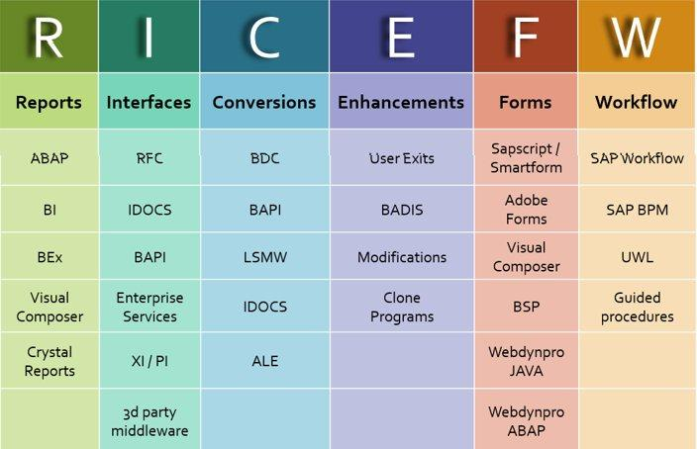

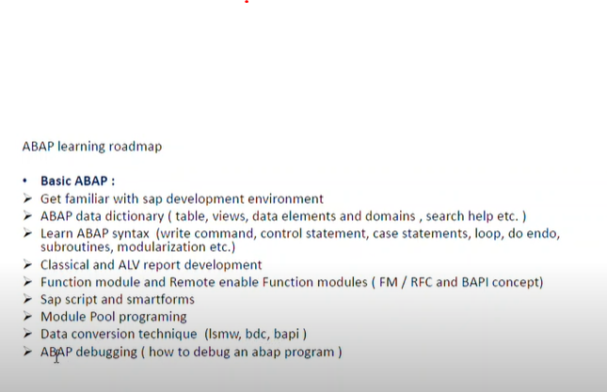 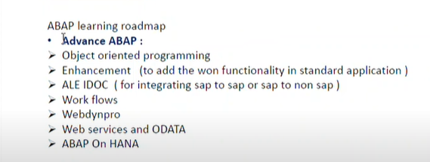

SE11 – Data Dictionary

SE38 – ABAP Editor

SE80 – Object Navigator

All the custom objects will start from **Z or Y**

**SE10 – Transport Request**

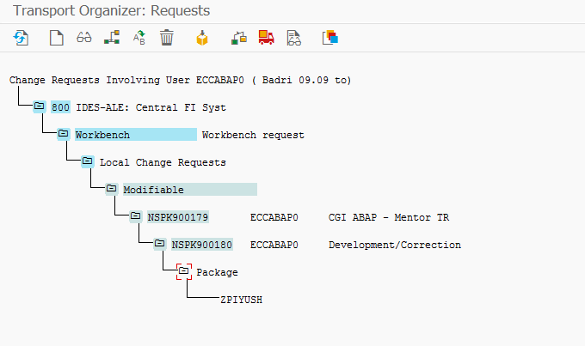

Session Overriding with another Transaction Code – use /n followed by new Transaction Code

Ex: You are currently in Object Navigator (SE80) and you want to go to Data Dictionary (Se11)

In command filed 🡪 /nse11

/nEND -> Ending all the sessions in a go with confirmation message.

/nEX -> Ending all the sessions in a go without any confirmation message.

/n -> Overwriting the existing screen

/o -> New Session

/I -> Kill / End the current session

Table: Collection of Row and Column

| F1 | F2 | F3 |
| --- | --- | --- |
|  |  |  |
|  |  |  |

DDIC :



| F1 | F2 | F3 |
| --- | --- | --- |
|  |  |  |
|  |  |  |

Database

Difference between Transparent, Pool and Cluster Table

* Transparent - 1 to 1 || Pool and Cluster – N to 1

**DDIC (DATA DICTIONARY)**

**https://medium.com/@richa.solanki18/a-brief-introduction-to-abap-data-dictionary-fca97eba44cf**

**https://www.geeksforgeeks.org/what-is-sap-abap-data-dictionary-ddic/**

**DDIC(Data Dictionary) :** Central repository where we define and maintain obj related to SAP DB – metadata of SAP DB.

With the help of DDIC, we can create and maintain user-defined types, such as data elements, structures, table types, etc.

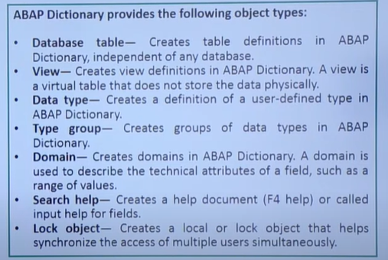

Domain : **technical attribute of the fields** such as length & datatype, value range that for that data element using this domain.

Data type : create structure and data element too

**Data elements** : These are used to specify the **types of the columns in the databases**. The data elements are of unstructured types that are used to provide the semantic information of the database table. It can be referenced as **TYPE** in the ABAP programs**. Semantic information of the table field such as short description**

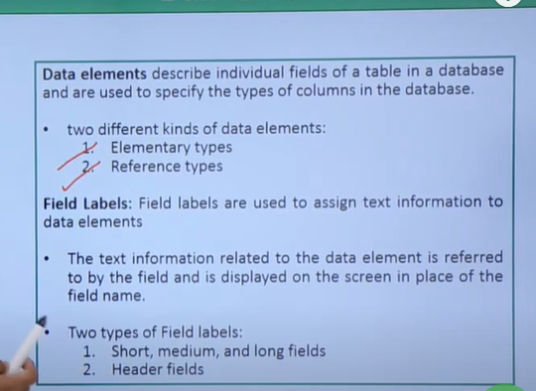

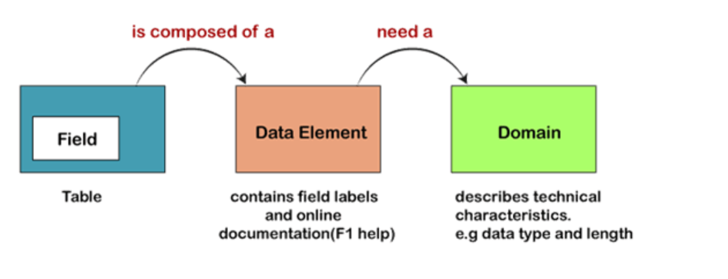

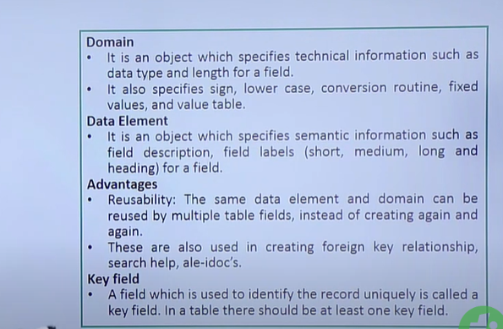

Structure :

* Same as table but here we will not have primary key / technical characteristics.
* Used to define work area in the prog.
* Can have single record at run-time.

Structures: On the basis of fields/components 3 different types of structures:

1. Flat Structure: refers to any Data Element / pre-defined type.

2. Nested Structure: at least one field contains another structure.

3. Deep Structure: one field pointing to table type 🡪 that table type itself pointing to a structure or a table.

**Structures are of 2 types:**

1. **Include**: type of structure which can be included at any position in a table / structure in custom tables only.

2. **Append**: which can only be included / appended at the end of a table/structure in the SAP tables.

Include Structure: Reuse the same set of fields in multiple places.

Append Structure: Add new fields to an existing table without changing the original

**Structure:**

* A structure is like a blueprint or template for organizing related data elements within a program or data object.
* It doesn't store data itself but defines the structure of data.
* Used for in-memory data organization and manipulation.
* Example: A "Customer Address" structure might have fields for street, city, postal code, etc.

**Table:**

* A table is like a database that stores actual data in a structured format, with rows and columns.
* It stores data, and you can query, update, or insert records.
* Used for data storage and management.
* Example: A "Sales Orders" table stores order data, including order numbers, customer IDs, product IDs, and quantities.

In simple terms, a structure is like a data arrangement plan, while a table is where the actual data is kept, like a spreadsheet or a database.

**Check Table** can be provided/validates at Field level -> checking that only permissible data is stored in database field. Ensure foreign key relationship or data relationship between two table.

1. **Functionality**: When a field in a table (known as a foreign key) references a field in another table (the primary key of the check table), the value entered into the foreign key field must exist in the check table.Enforce the entered data must be in check table.
2. **Usage Example**: Consider a field ‘Country Code’ in a customer table. The check table for this field would be the table where all valid country codes are stored. Only country codes that exist in the check table can be entered for the ‘Country Code’ field in the customer table.

Link : https://medium.com/@mansi89mahi/sap-check-tables-and-value-tables-e148ca931af5

**Value Table** can be provided at Domain level -> suggest/ provide list of values to be given for a particular field at domain level.

1. Functionality: When a domain is assigned a value table, it suggests that the entries for fields with this domain should ideally be from the values in the value table.
2. Usage Example: If a domain ‘City Name’ is assigned a value table containing a list of city names, it suggests (but does not enforce) that the values entered in any field referring to this domain should be one of these city names.

**Delivery & maintenance tab:**

**Delivery Class:** Controls the transport of table data-> how database table is going to be transported during installation, upgrade, and copies within landscapes, clients and customer systems.

Types : A , C , L

**Technical Setting of a table:**

* **Data Class:** type of data which will be maintained in the table or in which portion of sap db the table data is stored.
  + **Master Data:** accessed frequently but rarely changed. **AAPL0**
    - DOB, Permanent Address etc.
  + **Transaction Data:** which can be frequently accessed and update. **APPL1**
    - Salary, Current Address, Project Names etc.
  + **Configuration data:** contains the customizab;e data defined while system configuration and can be rarely changed. **APPL2**
    - Company Code, Country Code etc.
  + USR, USR1 🡪 Cust.data ->provided for user developments.
* **Size Category:** Data volume of the table –>How many records a table will contain 🡪 probable value or
  + 0 – Range (1 to 1000) 🡪 Example
  + 1 – Range (1001 to 10000)
  + 2 – Range (10001 to 50000)
  + 3 - Range
  + 4 - Range
* **Buffering:** allows you to access data quicker by letting you access from the application server
* **Logging:** Modification to the entries of a table can be recorded and stored using logging.

**Table Creation: 2 different approaches**

* **Top Down:** Table 🡪 Data Element 🡪 Domain
  + Creating Table
    - Data Element
      * Domain
* Bottom Up: Domain 🡪 Data Element 🡪 Table
  + Domain
    - Data Element
      * Create Table and incorporate Data Element and Domain

**Views:**

A view acts like a virtual table - a table that does not have any physical existence. It is not stored physically means no occupy the memory space.

* Collection of fields from multiple tables.
* Not store any data.
* View -> display data by selecting from multiple tables.
* Create view -> need to join the tables.

**Joins :**

Need to have a atleast one common key to join the table.

Inner Join : Only the matching recored from two/multiple tables will be selected.

Outer Join : All the records from 1st table will be displayed.

If there is a Matching records in the 2nd/3rd table -> displayed it.

If there is no Matching records in the 2nd/3rd table -> will display as blank.

Types:

DB view :

Created on 2/more tables by clubbing the fields using inner join -> DB View.

Only read . no maintenance operation made.

Can select entire table too.

Projection view :

Just retrieves some fields from a single table.

Created on single table.

Project only the wanted fields means filter unwanted fields.

Read and maintain the data.

Performance increase->minimize the fields.

Help View:

Created on 2/more tables for search helps using outer join -> Help View

Only read data.

Maintenance view :

It helps in creating the maintenance data and the data can be distributed into several tables. In real time we do not create maintenance views because the data multiple tables leads to inconsistency.

Created on 2/more tables by inner join -> Maintenance View.

Read and maintain data.

Not created on std tables. Create on custom table.

If we create this view on std table->Data inconsistency problem will come -> when change record in std tables.

Create a table related to Student Information

1. Name
2. ID
3. USN
4. Dept
5. Contact
6. DOB
7. Email
8. Address
9. Percentage
10. Gender

Create a Student table with name ZSTU_<name> and save it in <name> package

1. MANDT
2. Stud_ID
3. Stud_Fname
4. Stud_Lname
5. Stud_Gender 🡪 Fixed Values 🡪 M / F / O
6. Stud_DOB
7. Stud_contact
8. Stud_Email
9. Stud_Addr1
10. Stud_Addr2
11. Stud_city 🡪 Mumbai, Delhi, Bangalore, Hyderabad, Kolkata
12. Stud_state
13. Stud_Postal
14. Stud_Dept 🡪 MCA , BCA, BTECH, MSC etc
15. Stud_Hobby 🡪 Singer, Dancer, Painter, Photographer
16. Course_id
17. Course_name

Assignments to create multiple tables:

* Teachers
  + Teach_ID<_05>
  + Fname
  + LName etc etc
* Subjects
  + Subject_id
  + Subject_name
  + Course_id
  + Grades
* Courses
  + Course_id
  + Course_name

**Table Maintenance Generator ( )**

**Tool used to maintain the data.**

Instead of entering data one by one in the se11->utility->table content.

To mass upload /maintain data , TMG is created.

It is a tool to ***generate a table maintenance program*** i.e. it will generate a program to maintain (Create, Edit & Delete) entries in a table.

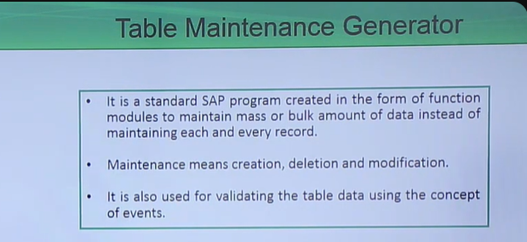

SE11 🡪 ZTable 🡪 Utilities 🡪 Table Maintenance Generator 🡪 Provide Inputs

* Authorization Group
* Function Group
* Maintenance Type : One Step / Two Step
* Maintenance Screen: Overview / Single 🡪 Find Screen Number (propose Scrn. No.)

Authorization Group:

This is like a permission group. It controls who can access and edit the data in a certain table. It's like giving keys to the right people.

Function Group:

Assign the Function Group where the generated FM will belong to.

Maintenance Type (One Step / Two Step):

How maintenance operations will take/happen.

One step table maintainance has only one screen. The entries in the table are displayed and modified and also created in only one screen.

Two step table maintainance, we have two screens. The first screen is used to display the table entries whereas we create and modify the records in the second screen

Maintenance Screen (Overview / Single):

This is about how the data looks on the screen. In an overview, you see a list of data. In a single screen, you look at one piece of data at a time, like a detailed form.

Find Screen Number (propose Scrn. No.):

It's like giving each screen a number, so you know which screen you're on. Think of it as labeling each screen to keep track of them.

**In case of + Sign appearing in your TMG for any fields, follow below steps:**

* Double Click on Maintenance Screen Number
* Select Element List
* Select Texts/I/O/Templates
* Replace + with respective texts for the fields

**Assignment 2:**

* Create a Package 🡪 zcgi_name09 (example)
* Use / Create a new Transport Request (TR) for this assignment
* **Create 2 Tables**
  + **Zflight_<09>**
    - Airline Code
    - Flight Connection Number
    - Flight date
    - Airfare
    - Local currency of airline
    - Aircraft Type
    - Maximum capacity in economy class
    - Occupied seats in economy class
    - Total of current bookings
    - Maximum capacity in business class
    - Occupied seats in business class
    - Maximum capacity in first class
    - Occupied seats in first class
  + **Zbook_<09>**
    - Airline Code
    - Flight Connection Number
    - Flight date
    - Booking number
    - Customer Number
    - Customer type
    - Smoker
    - Weight of Luggage
    - Booking Date
* Create Table Maintenance Generator for both the tables
* Keep Maintenance Type as One Step for ZFLIGHT_<09> and Two Step for ZBOOK_<09>
* Create 10 relevant Entries for both the tables

**How to adjust / remove inconsistency of a table – post structural changes.**

Go To SE14

**Assignment3:**

* Create an employee table for CGI (zempcgi_<name>)
* Include Structure for Name
  + First Name
  + Middle Name
  + Last Name
* Append Structure for Current Address
  + Address Line 1
  + Address Line 2
  + City
  + Street
  + Pin Code
  + Country
  + Landmark
* Include Structure for Permanent Address
  + Address Line 1
  + Address Line 2
  + City
  + Street
  + Pin Code
  + Country
  + Landmark

**Employee Table**

* Employee ID (Primary Key)
* Employee Start Date (Primary Key)
* Employee End Date (Primary Key)
* Official Mail ID
* PAN Card
* Aadhar ID
* Passport
* Designation
* Department / BU
* Salary
* Bonus
* Manager (N)
* N+1 (Manager’s manager)
* Highest Education

Standard Tables:

* MARA
* MARC
* VBAK
* VBAP
* VBRP
* BSEG
* PA0001
* PA0002
* PA0006
* PA0008
* KNA1
* KNB1
* KNBK
* LFA1
* T001

Transaction Code: SE16 / SE16N:

Lock Objects:

Lock objects in SAP are used to prevent multiple users from making changes to the same data at the same time.

Controls the access to data records in sap.This helps avoid conflicts and ensures that the data remains consistent and not corrupted.

* Naming conventions starts with E followed by your table name.
* To avoid inconsistencies.
* When Lock Object is activated, two-function module are created like ENQUEUE_<lockobjectname> and DEQUE.

Different Types of Locks:

* Write/Exclusive lock:
  + restrict multiple users to edit the same entry at one time. Only one person can modify the data at one time.
  + Only one user or session can hold an exclusive lock on a piece of data at a time.
  + Other users are prevented from both reading and writing to the data while the lock is in place.
  + Used when data needs to be updated or deleted, ensuring that no other operations can occur on the data until the lock is released.
* Read/Shared lock:
  + Multiple users will be able to read the same data simultaneously 🡪 one user try to edit a specific data which all the users are reading 🡪 the current edited data will not be available for others until and unless the data will be saved and other users refreshes the display.
* Exclusive but not cumulative: 🡪 lock will be requested only once.

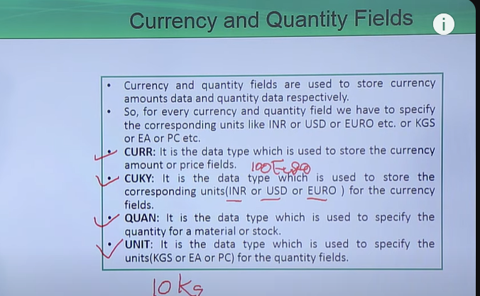

Type grp :

* Type group is used to declare different type declarations under a single group in data dictionary.
* This enables us to globally declare a custom type and use it in multiple programs using TYPE-POOLS statement.
* In addition to Types,Constants can also be created in it.
* Some of the commonly used SAP standard type groups are SLIS,

ABAP

ABAP: Advance Business Application Programming. Using ABAP, solutions can be developed for business applications such as MM (Material Management), SD (Sales & Distribution), PP (Production Planning) etc.

ABAP/4 🡪 4th generation Language Technique

1st Generation 🡪 Machine Level

2nd Generation 🡪 Assembly

3rd Generation 🡪 High Level / Readable languages

4th Generation 🡪 ABAP is a 4th Generation where we don’t have any Case Sensitive issues.

**Conversion Routines / Exits:** Depending on the data type of a particular field,

* converts the display format to SAP Internal format.
* Ex: Selection Conditions in views 🡪vbeln 🡪 4969 it wasn’t accepting it instead we had to give 0000004969

Create a ABAP Program displaying below output:

**Program Name: zfirst_<name>**

Hi! My Name is <>.

I am working in CGI.

I am learning SAP ABAP.

**Elements in ABAP Editor:**

* Source Code:
* Variants: save input values in selection screen 🡪 Variants
* Attributes: Title, Type, Status, Package, Who has created, when the program was created etc.
* Documentation: Program documentation stating features, output, prerequisites etc about the program.
* Text Elements: List and Column Headers, Selection texts in Selection Screen etc.

**Program Types:**

* **Executable Program:** capable to execute the program independently.
* **Function Group:** collection of Function Modules.
* **Include Program:** part of the main program which needs an executable program for it’s execution. It can’t execute independently.
* **Module Pool:** linked with the Screen painter.
* **Interface Pool:** collection of interfaces.
* **Class Pool:** collection of classes.
* **Subroutine Pool:** collection of subroutines.
* **Type Pool:** collection of types.

**Statement / Instruction:** Group of Keywords + Variables + Operators + Data Types + Constants etc.

**Keyword:** Whose meaning is already known to the SAP System. Keywords are categorized according to their functionality:

* **Declarative Key Words:** to declare variable, constants etc
  + DATA is used to create data object in runtime and allocates space fo it.
  + TYPES creates data type and does not allocate any space like structure.
  + TYPE refers to a pre-defined DATA TYPE
  + LIKE refers to pre-defined DATA OBJECT.
  + Ex: TYPES, DATA, CONSTANTS etc.
* **Database Key Words:** to work with Database operations
  + SELECT – to select the data from the table
  + INSERT – to insert the data into the table
  + UPDATE – changes or modify the data of a table
  + DELETE – to delete the data of a table
* **Controlling Key Words:** to control the default flow of the program.
  + If/Else/Endif
  + DO/ENDDO etc
* **Definition Key Words:** used to define the re-usable modules / blocks.
  + FORM – ENDFORM
  + FUNCTION – ENDFUNCTION
  + MODULE – ENDMODULE etc
* **Calling Key Words:** used to call re-usable modules / blocks that are already define.
  + PERFORM
  + CALL FUNCTION
  + MODULE
* **Event Key Words:** used to define the events.
  + TOP-OF-PAGE – print the same heading in the TOP of every page
  + END-OF-PAGE – print the same footer for every page of the output list
* **Operational (Miscellaneous) Key Words:** 
  + WRITE
  + MOVE
  + ADD.

**Selection Screen:**

Designed when user wants to accept/give data input.

* **Parameters:** Used for single entry. Parameter name can be 8 characters long.
  + PARAMETERS: p_matnr type mara-matnr.
* **Select Options:** Used for Single, Multiple and Range of entries. Select Option Name can be 8 Characters long. Need to include Table name which we are using in Select Options (Tables: MARA).
  + SELECT-OPTIONS: s_matnr FOR mara-matnr.
  + **Selection Table:** elements of selection table
    - **SIGN:** row condition 🡪 Include or Exclude the values from Select Options
    - **OPTIONS:** Operators 🡪 EQ, GE, LE, GT, LE etc.
    - **LOW:** defines the lower limit of Select Options
    - **HIGH:**  defines the higher limit of Select Options
* Buttons (Command and Push Buttons): Trigger actions or events when clicked ->parameter.
* Check Box: Allows users to select or deselect an option (Yes/No, True/False) - parameters
* List Box: Presents a drop-down list of options for users to choose from -parameters.
  + https://sapcodes.com/2015/11/22/list-box-at-selection-screen/
* Tab Strips: Organize content into tabs, with each tab containing different elements or data.

----------------------------------------------------------------------------------------------------------------------------------

* Parameters:
  + type VBAK-VBELN
  + type c obligatory
  + type c default ‘X’
  + type <table-field> **matchcode object <search help name> - used search help in the program.**
  + type mara-matkl no-display
  + 3 check boxes
  + 5 radio buttons
    - 3 radio button group LB1
    - 2 radio button group LB2
* Select-Options:

**Assignment on Selection Screen:**

* Create multiple Select Options:
  + 5 Select-Options from zflight table which you have created earlier
    - Create 1 with default values
    - Create 1 with No extension
    - Create 1 with No Display
    - Create 1 with No Intervals
    - Create 1 with No Extension No Intervals Default Value
  + 4 Parameters from zbook table which you have created earlier
    - Create 1 parameter as Mandatory field
    - Create 1 parameter assigning Search Help
    - Create 1 parameter with default value
    - Create 1 parameter with no display
  + Create 3 different Check box
  + Create Radio Buttons

**Pretty Printer:** Helps in beautifying the code / modify the indent of control flow statements, loops, structures etc.

**How to set up and change default pretty printer setting?**

Utilities 🡪 Settings 🡪 Pretty Printer

Assignment on Formatting the Selection Screen:

* Create 3 different blocks
  + First block contains 2 Radio Buttons
    - LFA1
    - KNA1
* Create 2 Parameters for each table in separate blocks

SELECTION-SCREEN: BEGIN OF LINE.  
 PARAMETERS: p_chk1 AS CHECKBOX.  
 SELECTION-SCREEN POSITION 1.  
 SELECTION-SCREEN COMMENT 3(10) text-003.

SELECTION-SCREEN: END OF LINE.

**Report :**

R**eports** are used to retrieve and display data from the database in a structured and organized manner. Presentation of data in a specific format and organised structure.

**Different Types of Reports:**

* Classical: https://medium.com/@ssamruddhi.k2015/classical-report-in-sap-abap-b168511423c4

**Basic output list** (c/c++) 🡪 no manipulation (sort, change the column position etc) can be done in output. Output will be single list. SAP ABAP classical reports are the most basic ABAP reports in which we displayed the output in the **single list** using WRITE statement

* ALV (ABAP List Viewer): manipulate the report output like sorting,filtering etc.., output display list / grid /tree hierarchy format ->done using FM ->REUSE_ALV_LIST/GRID-Display. <https://www.saphub.com/abap-tutorial/what-is-abap-alv/>
* Interactive: from one output if you want you can have another output based on some condition.

The user can actively control data retrieval and display during the session. Instead of an extensive and detailed list, you create a basic list with condensed information from which the user can switch to detailed displays by positioning the cursor and entering commands. The detailed information appears in secondary lists

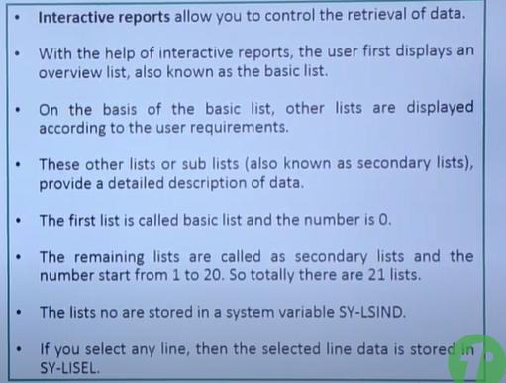

* + Classical Interactive
  + ALV Interactive

**Events:**

In SAP ABAP, events are predefined points in a program where certain actions take place. They help control the flow of the program and determine when specific blocks of code are executed. Here’s a simple explanation:

Events: Think of them as triggers or checkpoints in a program. When an event occurs, the corresponding code is executed.

**Classical Report events:**

* Load of Program 🡪 something (program) being loaded into memory for execution 🡪 Internal Memory->internal event.
* Initialization 🡪 load all the default values to the prog variable.
* AT Selection Screen: All these events will be used for validations of multiple fields in sel.screen , modify the sel-screen etc .
  + At Selection Screen Output 🡪**modify the sel.screen dynamically based on user actions on the sel.screen-**> modify the selection screen dynamically, such as hiding or showing fields based on certain conditions. want to hide one input field based on selection of screen elements
  + At Selection Screen on value request 🡪 F4 Validation – Provide list of possible values for a particular field in sap selection screen.
  + At Selection Screen on Help request 🡪 F1 Validation(info about particular field) - provide custom help text, documentation, or even execute custom logic to guide the user on how to fill in or use a particular field..
  + At Selection Screen on Field 🡪 validates at field level 🡪 Parameters / Select Options etc 🡪 single field validation.
* Start of selection 🡪 starting point of the prog ->main body of your program 🡪 main business logics, list processing, all select statements etc. Main processing logic for selecting and preparing data
* End of selection 🡪 triggered once logical database has finished reading all the data and before output is being displayed. Post-processing tasks after the main logic.
* Top of Page -> show information on top of page.
* End of Page -> show information on footer.Provide line count.
* AT USER-COMMAND
  + **Purpose**: This event is triggered when the user executes a command on the selection screen, such as pressing a custom button. It allows you to handle custom user actions.
  + **Typical Usage**: Handling custom buttons or commands on the selection screen.

**Interactive report events:**

* At Line-Selection – trigger when user click on the line in output list -> store the content of selected line by using **HIDE Keyword** which will be used to display the detailed information about it in secondary list.
* AT User-command
* When user clicks on the functions created using pf-status(own GUI status on the screen), at that time at user-command event triggers.
* The system variable sy-ucomm is used to capture the value of function code.

To create own GUI status functions, we need to use **SET PF Status ‘NAME’**.

* Top-of-page during line selection - Defines headers for the secondary list created during interactive reporting.
* **GET CURSOR:**Trigger the events based on the field level selected in the report to generate/populate the relevant info.

Data Types:

* Pre Defined
  + I - Integer => 4
  + C – Character => 1
  + N – Numeric => 1
  + P – Pack => 8(Like Float but we can define decimal places)
  + D – Date => 8
  + T – Time => 6
  + F – Float => 8
  + Xstring => Hexadecimal String
  + String => not specified
  + Decfloat16 => 8 byte and 16 Decimal Places
  + Decfloat34 => 16 bytes and 34 Decimal Places

**Assignment on Classical Report 1:**

Create a program and do addition, multiplication, subtraction and division for 2 numbers and store and display the output in third variable. Declare default values and do the operations.

**Assignment on Classical Report 2:**

Create a program and do addition, multiplication, subtraction and division for 2 numbers and store and display the output in third variable. Consider inputs from User through Selection Screen

Logical Expressions: IF/ELSE, CASE

Logical Operators: AND | OR | NOT

Relational Operator: **=**/**EQ**, **<>** / **><** / **NE**, > / GT, < / LT, <= / LE etc

String Comparison Operator: str = Sachin Ramesh Tendulkar | str = Tendoscate

* CO: Contains Only | Case Sensitive | Blanks will not be ignored
* CA: Contains Any | Case Sensitive | Blanks will not be ignored
* CS: Contains String | Not Case Sensitive | Trailing blanks can be ignored
* CP: Contains Pattern | Not Case Sensitive | Trailing blanks can be ignored
* CN: Contains Not Only
* NA: Contains Not Any
* NS: Contains No String
* NP: Contains No Pattern

**Calculation & String Operation:**

* Assigning Values
  + Copy number1 into number2
    - Number2 = number1.
    - Write number1 to number2.
    - Move number1 to number2.
  + Multiple Assignments
    - Number4 = number3 = Number2 = number1.
  + Move values of 1 strc to another
    - MOVE-CORRESPONDING <strc1> to <strc2>.
    - Move strc1-<component_name> to strc2-<component_name>.

**Flow Control Statement:** heart of any programming languages which brings intelligence. Deals with the complex and alternative solutions.

IF / ELSEIF / ELSE ---- ENDIF

If 10

<action>

Elseif 20

<action>

Else

<action>

**Assignment on Classical Report 3:**

Create a program and do addition, multiplication, subtraction and division for 2 numbers and store and display the output in third variable. Consider inputs from User through Selection Screen.

* Input Parameter Block
  + Number 1 🡪 Parameter
  + Number 2 🡪 Parameter
* Calculation Selection Block
  + Radio Button 1 🡪 Addition
  + Radio Button 2 🡪 Subtraction
  + Radio Button 3 🡪 Multiplication
  + Radio Button 4 🡪 Division
* Depending on the user selection of radio buttons, display the output

*\* Shortcut for Commenting cntrl + <*  
*\* Shortcut to UnComment cntrl + >*  
*\* Shortcut to activate cntrl + F3*  
*\* Shortcut to Save cntrl + s*  
*\* Shortcut to go back F3*  
*\* Shortcut to copy and paste duplicate line immediately cntrl + D*

Displaying / Hiding Fields of Selection Screen

*\*==================================================================\**  
*\* 2 ways we can approach this*  
  
*\* 1. If Mara Radio Button is selected*  
*\* Hide all the other fields which are not related to MARA*  
  
*\* 2. If Mara Radio Button is not selected*  
*\* Hide respective fields for Mara.*  
*\*==================================================================\**  
AT SELECTION-SCREEN OUTPUT.  
 LOOP AT SCREEN.  
 IF screen-group1 = 'MD1'.  
 IF p_rad2 EQ 'X'.  
 screen-active = 0.  
 MODIFY SCREEN.  
 ENDIF.  
 ENDIF.  
*\*==================================================================\**  
*\* 2 ways we can approach this*  
  
*\* 1. If VBAK Radio Button is selected*  
*\* Hide all the other fields which are not related to VBAK*  
  
*\* 2. If VBAK Radio Button is not selected*  
*\* Hide respective fields for VBAK*  
*\*==================================================================\**  
 IF screen-group1 = 'MD2'.  
 IF p_rad1 EQ 'X'.  
 screen-active = 0.  
 MODIFY SCREEN.  
 ENDIF.  
 ENDIF.  
 ENDLOOP.

**Assignment on Classical Report 4:**

* Create a program with 4 Radio Buttons
  + EKKO
  + EKBE
  + LFA1
  + KNA1
* Create / Declare 3 different Select Options for each Table mentioned in the Radio Button
* Hide / Display the respective fields of the table selected via Radio Button

CHECK Statement: if x =5 🡪 Logical Expression 🡪 Checks the logical expression

J = 10.

Do 10 times.

Check j LE 15.

Write: ‘Value of J is:’, j.

J = J + 1.

ENDDO.

| **Employee Table** | | |  |  |  | **Department Table** | | |
| --- | --- | --- | --- | --- | --- | --- | --- | --- |
| **Emp ID** | **Emp Name** | | **Dept ID** | | --- | |  |  |  | **Dept ID** | **Dept Name** | **Emp ID** |
| 1 | Praveen | 101 |  |  |  | 101 | Science | 1 |
| 2 | Subash | 102 |  |  |  | 102 | Commerce | 2 |
| 3 | Harsha | 103 |  |  |  | 103 | Art | 3 |
| 4 | Roshini | 101 |  |  |  | 101 | Science | 4 |
| 5 | Aparna | 102 |  |  |  | 102 | Commerce | 5 |
| 6 | Devishri | 103 |  |  |  | 103 | Art | 6 |
| 7 | Khalid | 101 |  |  |  | 101 | Science | 7 |
| 8 | Prathmesh | 102 |  |  |  | 102 | Commerce | 8 |
| 9 | Devishri | 103 |  |  |  | 103 | Art | 9 |
| 10 | Piyush | 101 |  |  |  | 101 | Science | 10 |

Check Table can be provided at Field level.

**Value Table** can be provided at Domain level.

**SQL:** Structured Query Language 🡪 standard programming language which can be used to manage database and perform multiple operations on the data of tables in db.

* Store 🡪 Insert
* Manipulate 🡪 Update, Modify, Delete
* Retrieve 🡪 Select

Select:

* Read Operation / Extract the data
* Select <field1> <field2> <field3> from <table_name> into table <internal_table_name>.

Internal Tables holds the data during runtime only.

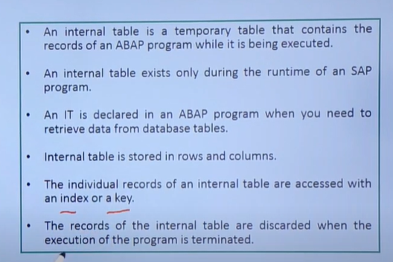

x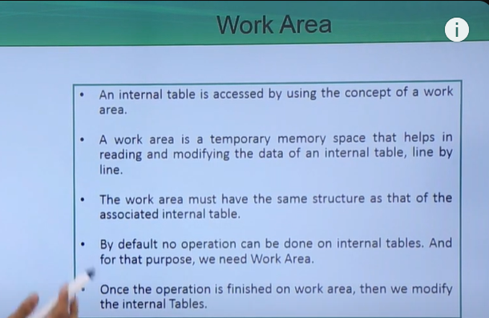

Operations on IT : https://abap4help.blogspot.com/2020/04/sap-abap-internal-table-operations-and.html

**Assignment Classic Report 5:** Create an executable program for LFA1 Table. Extract 10 fields of LFA1 Table and display it as an output. **Use LIFNR as Select Options.**

**Assignment Classic Report 6:** Create an executable report by joining EKKO and EKAN Tables. Provide EBELN as Select Options. Use events while creating the report.

**Assignment Classic Report 7:** Create an executable report with the below details:

* Radio Buttons:
  + MARA and MARC
    - If MARA and MARC Radio Button is selected then show only Material Number Select Options.
  + VBAK AND VBAP
    - If VBAK and VBAP Radio Button is selected then show only Sales Document Select Options.
* Join Operation
  + Consider 4 fields from Mara and Marc respectively for Join Operation
  + Consider 4 fields from Vbak and Vbap respectively for Join Operation
* Display Output
  + Display Output for Join between Mara and Marc only if MARA AND MARC Radio Button is selected
  + Display Output for Join between VBAK and VBAP only if VBAK and VBAP Radio Button is selected

**Assignment on String Operation:**

1. Declare a variable with value ‘Mr.’
2. Declare a variable with value ‘Steven’.
3. Declare a variable with value ‘Smith’.
4. Concatenate all the 3 values into 1 single value and display the value followed by a blank straight line.
5. Add spaces after concatenation and display the result in new line.
6. Declare a variable with value ‘Mr. Steven Smith’ and then print the output without any gaps.
7. Find the total length of String ‘Mr. Steven Smith – the Australian Captain’.
8. Replace Captain with Cricketer
9. Search Smith in the above string and if found print the value of system fields sy-subrc and sy-fdpos.
10. Split the values found in 4th Step into separate contents and display them as an output
11. Declare a character variable with phone number as ‘+91-(033)-9834567890’
12. Display the Country Code from Phone Number.
13. Display City Code from Phone Number
14. Display phone Number without Country and City Codes.

**Message Class 🡪**  Go TO Transaction SE91 🡪 Message Class Name 🡪 Input Messages in front of Message Numbers 🡪 Save it.

How to use Message Class?

Ex: Message i000(zmsg_mentor) with <constant / variable> 🡪 & exist in the Message

Message i000(zmsg_mentor) 🡪 no & exists in the message

**Sample Assignment on Message Class:**

Create 1 parameter with Personnel Number. Check that personnel number exists or not. In case on non-existence of PERNR display Error Message <PERNR> doesn’t exists using Message Class and Message ID.

**Note: In Message ID, kindly include & to fill the PERNR dynamically.**

**Assignment on Classical Report 8:**

* Create 4 Radio Buttons (all in 1 Block)
  + Material Data
  + Purchase Documents
  + Sales Document
  + HR Information
* Create all the other details / points in different blocks
* Create 1 Parameter for Total Number of Rows. Put validation that total number of rows should not exceed 1000.
* **For Material Data,** create a Parameter for Material Number.
  + Put validation on Material Number
  + If no Material Number and no No. of Rows has been inputted, populate an Information Message that ‘Material Number is blank’.
  + If no Material Number but total number of Rows has been inputted then extract that many materials from respective Table.
  + Based on the inputted Material Number, display Material Number, Material Type, Material Group, Maintenance Status, Valuation Category, Plant Specific Material Status, Purchasing Group and MRP Type as the output.
* **For Purchasing document,** create a Parameter for Purchasing Document.
  + Put Validation on Purchasing Document
  + If no Purchasing Document and no No of Rows has been inputted then populate an Error Message stating ‘Purchasing Document can’t be blank’.
  + If no Purchasing Document has been inputted then extract that many Purchasing Documents from the respective table.
  + Based on the inputted Purchasing Document, display Purchasing Document Number, Company Code, Purchasing Document Category, Purchasing Document Type, Status of Purchasing Document, Material Document, Posting Date, Quantity and amount as the output.
* **For Sales document,** create a Parameter for Sales Document.
  + Put validation on Sales Document
  + If no Sales Document and no No. of Rows has been inputted then populate an Information Message stating ‘Sales Document can’t be blank’
  + If no Sales Document has been inputted then extract that many Sales Documents from the respective table.
  + Based on the inputted Sales Document, display Sales Document Number, Document Category, Document Type, Transaction Group, Warranty Date, Material Number, Batch Number, Material Group and Short Text for Sales order item as the output.
* **For HR Information,** create Personnel Number as parameter from table PA0000.
  + Put validation on Personnel Number
  + If no Personnel Number has been inputted then populate an information Message stating ‘Input Personnel Number’.
  + If no Personnel Number but No. of Rows has been inputted then extract that many Personnel Numbers from Table PA0000.
  + Based on the inputted Personnel Number, display Personnel Number, Start Date, End Date, Changed On, Changed By, Action Type, Reason for Action, Customer Specific Status, Employment Status and Special Payment Status as the output.
* Use all the Events which as necessary and required in this report

**Assignment on Classical Report 9:**

* Extract Personnel Number, Customer Specific Status, Employment Status, Special Payment Status from Table PA0000.
* Based on Personnel Number extracted from PA0000, extract Company Code, Personnel Area, Employee Group, Organizational Key, Payroll Area, Cost Center from Table PA0001.
* Based on Personnel Number extracted from PA0000, extract First Name, Last Name, Gender, DOB, and Nationality from PA0002.
* Based on Personnel Number extracted from PA0000, extract Bank Key, Bank Account Number from table PA0009
* Based on Bank Key extract Bank Name from BNKA Table
* Display all the fields which has been extracted as an output and also make sure that for name you don’t show first name and last name separately – concatenate it and display it in the output, for Gender you just don’t display the Gender Key – provide Male / Female as an output.
* Selection Screen:
  + Select Options:
    - Personnel Number
    - Employment Status
  + Parameters:
    - Company Code
    - Business Area
    - Employee Group

**Control Break Statements:** You can divide the sequences of entries into groups based on the contents of certain fields. Control Level Processing is allowed within a Loop over an Internal Table.

Control break events in SAP ABAP refer to events triggered during the processing of internal tables when a specific condition changes or breaks the sequence of data. These events are useful for performing calculations, aggregations, or displaying subtotals based on changes in key fields within the table.

* Internal Tables are divided into groups according to the sequence of the fields in the line structure / column structure.
* Different Control Break Statements:
  + AT FIRST: First line of the internal table
  + AT LAST: Last line of the internal table
  + AT NEW: Beginning of a group of lines with the same contents in the field <F1> and in the fields left of <F1>
  + AT END OF: End of a group of lines with the same contents in the field <F1> and the fields left of <F1>
* **Internal Table should always be sorted wrt key fields or fields which we will consider for Control Break.**

**Modularization Techniques:** **They are used to organize your ABAP Code**, make the program more understandable and also we can have code re-usability (avoiding code duplication). **Divide the program into small modules/program for btr readability and reuseability.**

Types of modularization techniques:

* **Constants and Text Symbols:** They are used to avoid the hard coded texts and we can reuse them in the program. The main difference between text symbols and constants is – text symbols can be translated in different languages but Constants can’t be translated.
* **Message Class:** They are used to give messages for **instructing the users**. Users can analyze the message and can re-enter the inputs. Different type of Messages:
  + **E (Error):** Stops the next part of program. In the status bar, get a message with X mark with Red BG Color.
  + **S (Success):** You get a tick mark in the status bar and next part of the program will continue.
  + **W (Warning):** You get an ! Mark with Yellow BG, you have to press Enter to start further execution.
  + **I (Information):** You get a pop up window with symbol ‘I’, the program will continue to execute.
  + **A (Abort):** It exits out of the program to SAP initial Screen once exit button is pressed.
  + **X (eXit):** It will terminate the program by giving short dump or runtime error.
* **Include Program:** These are the programs which can’t be executed independently. We need an executable program for the execution of an include program. The source code in the include program can be re-used in any program across the system by calling them. Can’t call another include prog inside one include program.
  + **Syntax:** INCLUDE <Include_Name>
  + Create a program with below details:
    - 2 Radio Buttons
      * Arithmetic Operation
      * String Operation
    - If you click on Arithmetic Operation you will get 4 Radio Buttons
      * Add
        + 2 Parameters – Number 1 and Number 2
      * Sub
        + 2 Parameters – Number 1 and Number 2
      * Mul
        + 2 Parameters – Number 1 and Number 2
      * Div
        + 2 Parameters – Number 1 and Number 2
    - If you click on String Operation you will get 3 Radio Buttons
      * Split
        + 1 Parameter only for giving Texts
      * Concatenate
        + 2 Parameters – String 1 and String 2
      * Replace
        + 2 Parameters – String 1 and String 2
    - Based on the Radio Button Selection, show the output
* **How many ways to create an Include Program:** 
  + Go to SE38 and Create an Include Program
  + Double click on Include Name declared in an Executable Program

**Subroutines:** These are **local modularization** techniques – scope of subroutines are inside that program only. They are generally called from the program in which they are defined.

* Subroutines should be called First and Defined next in the program.
* No Statements can be executed after calling the Subroutines.
* Syntax:
  + PERFORM <Sub_Name> using <input1> changing <input2>
    - Form….endfform.

<https://www.tutorialscampus.com/sap-abap/subroutines.htm>

PERFORM <Sub_Name> using <input1> -

Form <Sub_Name> using <inp1>. – pass by reference (which is locating to same memory allocation.) .Change in inp1 will also change the value of input1(calling parameter).

Form <Sub_Name> using value<inp1>. – Pass by value. Change in inp1 will not change the value of input1(calling parameter).

PERFORM <Sub_Name> changing <input1>

using v1 and changing v1 – pass by reference

using value(v1) – pass by value.

Changing value(v1) - pass by value and result.

Assignment for Classical Report with Subroutine:

* Selection Screen: (SFLIGHT)
  + Airline Code – Select Options
  + Flight Date - Parameter
  + Air Fare - Parameter
    - Output Fields: Airline Code, Flight Connection Number, Flight date, Airfare with Currency, Aircraft Type, Number of seats empty in Economy Class, Number of Seats empty in Business Class.

**Macros:** If you want to reuse the same set of statements more than once in a program, we can include them in Macro. Syntax: DEFINE <macro_name>

----------------------------

END-OF-DEFINITION

**Function Module:** Global **Modularization Technique**. Sub-programs contain set of reuseable statements with importing and exporting parameter. It can be excuted independently and pre-defined SAP fm.

SE37 is the tcode to create Function Module (FM).

* Each FM should always be linked to one Function Group.
  + Function Groups are containers for FMs.
  + You cannot execute a Function Group.
  + When you call a FM, the system loads the FM into Internal Session of the calling Program.
* **Different Types of Function Module:** 
  + **Normal Function Module:** They are defined and called in the same system.
  + **Remote Enables Function Module:** They are defined in one system and are called in another SAP or non-SAP systems. It is the cross-application component to provide an interface between 2 SAP systems and between SAP and non-SAP systems.
  + **Update Module:** They are used to update the databases (Tables etc).
* **Different Components of Function Module:**
  + **Attributes:** This tab contains the technical details of an Object – such as type of object (Normal FM, Remote Enables FM etc), Created By, Changed By, Function Group Name, Package Name etc.
  + **Import Parameter:** They are the parameters which can be imported from the calling program to the Function Module. They should be passed with the data unless they are marked as optional. They can’t be changed inside the Function Module.
  + **Export Parameter:** They are the parameter which can be passed from function module to the calling program. The export parameters are the optional parameter.
  + **Changing Parameter:** They are the parameters which can be imported from the calling program, changed the values and exported the changed values to the calling program.
  + **Tables:** They are used to import or export the internal tables.
  + **Exception Parameter:** They are used to raise the exceptions (messages) based on the return code (sy-subrc)
  + **Source Code:** The ABAP Code for implementing the business logic.
* **Difference between Function Module and Subroutine:**
  + Function Module: Global modularization Technique which are stored in a Function-Pool. But Subroutines are the local modularization technique.
  + Function Module can be executed independently using Transaction Code SE37. But subroutines can’t be executed independently.
  + Exceptions can be handled in Function Modules. But it can’t be handled in Subroutines.
  + Remote Enabled Function can be called across the system (non-SAP also). But Subroutines can’t be called across the system.
* Create a Function Module which will accept Material Number and it will display 10 fields from Marc Table.
  + Create a global structure with those 10 fields
  + Create a table type with structure
  + Create a Function group
  + Create a Function Module
    - In Tables Parameter use table type

**Debugger:** It is used to check the program or source code line by line and block by block for finding and rectifying the error or bug. Following are the different types of debugger:

* Classic Debugger: It is also known as Old Debugger. This debuggers open on the same session.
* New Debugger: This debugger is available from SAP Version ECC 5.0. This debugger opens in a new session.
* Shortcuts to check programs or source code in debugger:
  + F5 / Single Step: Function Key F5 is used to check line by line of the program.
  + F6 / Execute: We want to skip a subroutine or FM
  + F7 / Return: It is used to return from the source code of the process block such as subroutines, function modules etc.
  + F8 / Continue: It is used to jump from one break point into the next break point and then execute once the last break point is reached.

**Break Point:** They are used to stop the program or source code in the debugger tool for checking line by line or block by block. Up to 30 break points can only be set in a system. Different types of debugger:

* **Session Break Point:** An icon set or delete session break point (cntrl + shift + f12) or click on statement line at gray color vertical section in the source code. Once the program or source code has been modified, please make sure that you are activating the program or source code before setting the Session or External Break Points.

* **Static Break Point:** The ABAP Statement BREAK-POINT or BREAK<USER> is used to set static break point. In the real time, it’s not advisable to write BREAK-POINT – all the end users can start the debugger while executing the program.
* **Dynamic Break Point:** They are used to check the program or source code in case of not possible to find a location to set the debugger. The command /H or /h is used to set the dynamic break point.
* **External Break Point:** They are used to check cross application components such as RFC Function Module, BAPI etc.

**Watch Point:** They are used to stop the program or source code once the set condition is reached or true. Watch Points are defined inside the debugger only. Up to 9 Watch points can only be created.

**Classical Report Assignment 10 with List Box:** Create a Program with below details:

* Selection Screen:
  + List Box – contains Table Names
    - MARA
      * Material Number Select Option – 23 🡪 sent to FM 🡪 MATNR
    - EKKO
      * Purchasing Document Select Option
    - VBAK
      * Sales Document Select Option
    - SBOOK
      * Airline Code Select Option
* Parameter:
  + No. of Rows
* Based on selection of tables from list box and the number of rows provided in the selection screen, display at least 10 fields of that table.
* Selection Logic needs to be written inside Function Module.
* Use all the necessary EVENTS in the program
* Use Subroutines
* Use Include Programs
  + <program_name>_d – data declaration
  + <program_name>_s – selection screen
  + <program_name>_m – main logic with perform statement only
  + <program_name>_f – all subroutines
* Program Name: zassign10_<name>

**Reports:**

* Classical 🡪 Done
* Interactive(basic list (0) -> secondary list(1..20)
  + Classical Interactive 🡪 Starting
  + ALV Interactive
* ALV (ABAP List Viewer)

**Interactive Reports:** Displays the summarized information/general information as the first list and letting the User interact for the detailed information. **Note: We can go up to 20 Secondary List.** A

….

**What are the different ways of User Interactions and the corresponding event trigger for each type of user interaction.**

* Line Selection (Double Click) 🡪 AT LINE-SELECTION.
* User Commands (Click on Function Keys) 🡪 AT USER-COMMAND

Note: The List Index SY-LSIND will be incremented by 1 for each user interaction. It is Zero for Basic List, 1 for 1st Secondary List, 2 for second secondary list ….upto 20.

Useful System Fields for Details List – After each user action on a list, following ABAP System Fields will be set in the corresponding event block:

* **SY-LSIND:** Index of the list created during the current event (basic list = 0).
* **SY-LISEL:** Contents of the line from which the event was triggered.
* **SY-UCOMM:** Function Code that triggered the event.
* **SY-PFKEY:** Status of the list currently being displayed.
* **HIDE Keyword:** You use the HIDE Technique while creating a list level to store line-specific information for later use. It should be used always after the output (write) statement. HIDE maintains the copy of the output (corresponding) list. Used in Classical report only.

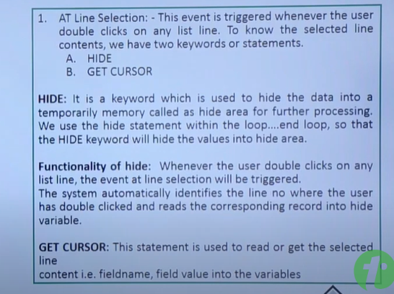

**Assignment on Classical Interactive Report 1:** Display the vendor details on basic list and purchasing header details for the selected vendor in the next secondary list. (LFA1 Table – Vendor Details – Vendor Number, Name, Country Key, City and Title | EKKO Table – Purchasing Header Information – Vendor Number, Purchase Document Number, Purchase Document Category and Purchasing Organization).

**Assignment on Classical Interactive Report 2:** Display Customer details on basic list and Sales Header details for the selected customer in the next secondary list and also display Sales items for the selected Sales Document. (KNA1 – Customer Details – Customer Number, Name, City, Postal Code and Region, VBAK – Sales Header – Sales Document Number, Document Date, Sales Document Category, Sales Document Type, VBAP – Sales Item Details – Sales Document Number, Sales Document Item, Short text for Sales Order Items Material )

AT LINE-SELECTION

SY-LSIND

SY-LISEL

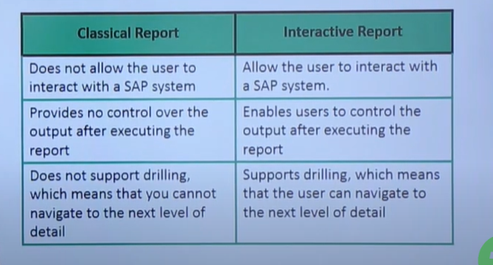

ALV:

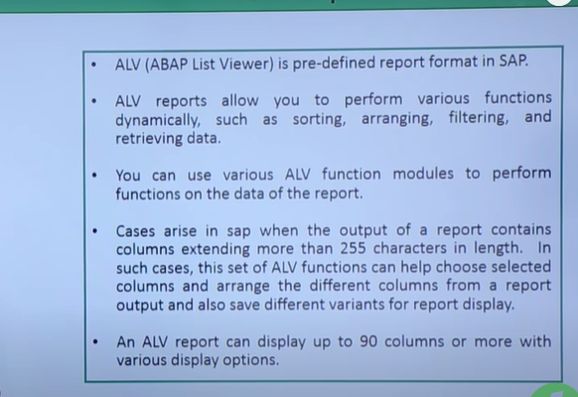

**Assignment on ALV Report:** Extract IDoc number, IDoc Type, Direction for IDoc, Basic Type, Message from EDIDC. Based on the IDoc number extracted from EDIDC extract all the status record of those idocs from EDIDS – Idoc Status, Text for status code, Type of system error message, No. of SAP Segment, parameter1, Parameter2, Parameter3 and parameter4 from EDIDS. Display the output in ALV Grid Format.

Selection Screen Design:

* Select Option: IDoc Number
* Parameter: Status

If you are not giving IDoc Number and giving Status so extract all the records with that current status from EDIC and join the fields extracted from EDIDS and display the output. Please make sure to display all the status of the idoc and not only the current status.

Put validation on IDoc Number and Status Select Options and Parameter respectively.

**Using Traffic Lights:** - indicate how urgently materials need to be processed

https://www.saphub.com/alv/traffic-lights-abap-alv/

icon TYPE c, "hold the traffic light value

gs_layout TYPE slis_layout_alv,

gv_prog TYPE sy-repid. "sy-repid will hold the name of current executed program

gs_layout-lights_fieldname = 'ICON'.

CALL FUNCTION 'REUSE_ALV_GRID_DISPLAY'

EXPORTING

I_CALLBACK_PROGRAM = gv_prog

IS_LAYOUT = gs_layout

**Hotspot :**

Hotspots are special areas of an output list. If the user clicks once onto a hotspot field, an event is triggered (for example, AT LINE-SELECTION ). For fields that are not defined as hotspots, the user must double-click the field or use a function key to trigger an event.

**Assignment on Traffic Lights:** Extract all the data from EDIDC and display traffic lights for below status

* Status 53 – Green
* Status 51 or 56 – RED
* Any other Status – YELLOW
* Display fields in ALV:
  + IDoc number
  + Status of IDoc
  + IDoc Type
  + Direction for IDoc
  + Receiver port (SAP System, EDI subsystem)
  + Partner Type of Receiver
  + Partner Number of Receiver
  + Recipient address (SADR)
  + IDoc Created On
  + IDoc Created at
  + Message Type
  + Basic type
* Use all the necessary events and do all the validations
* Design your own selection screen

**Assignment on ALV Report with Traffic Signal:** Create a report which will display an ALV Output with following fields:

* Selection Screen:
  + Select Options: IDoc Number
  + List Box(drop down): Ageing Days
    - Select Ageing Days 🡪 if this is selected you will throw an error message
    - 0 – 30 Days
    - 31 – 60 Days
    - 61 – 90 Days
    - GT 90 Days
  + Select Option: Created On (date)
  + Select Option: Status
* Extract the data based on IDoc Number, Date, Status and / or Ageing Days
* Extract only Error IDocs with status 51 and 56 if no status has been given in the selection screen
* Fields to display in the output
  + Exception Icon (Traffic Light)
  + IDoc Number
  + IDoc Status
  + Create On
  + Created At
  + Ageing Days 🡪 Current Date – Last Status Date
  + Error Analysis
    - Concatenate and Replace values of & from text for status code with STAPA1, STAPA2, STAPA3 and STAPA4
  + SAP Segment Number
  + SAP Segment Field Name
* **Make sure 1 IDoc has only 1 entry in the output**

**Assignment on ALV Interactive Report:**

* Extract Purchase Order details from EKKO – consider 10 fields.
* Extract the Purchase Order based on below Selection Screen:
  + Select Options: Purchase Document Number
  + Parameter: No. of Rows
* Extract based on selection screen input.
* Make sure no. of rows shouldn’t exceed 100.
* Put a hotspot at Purchase Document Number.
* Once you click on the hotspot created for PO Number – go to Transaction Code ME23 by passing the PO Number.

**Assignment on Interactive Report:**

* Create a Classical and ALV Interactive Report in a single program.
* Below are the selection screen design
  + **Radio Buttons**
    - **Classical Interactive**
      * If Classical Interactive Radio Button is selected below Radio Buttons will be displayed.
        + Shipping
        + Delivery
    - **ALV Interactive**
      * If ALV Interactive Radio Button is selected below Radio Buttons will be displayed.
        + Personnel Information
        + Organizational Information
* **Classical Interactive**
  + **Select Options:**
    - **Shipping**
      * Shipment Number
      * Shipping Type
    - **Delivery**
      * Deli.CHAN
      * Delivery Type
  + **Parameter**
    - **Shipping**
      * Destination Country
    - **Delivery**
      * Route
* **Shipping Extraction Details:** Based on the selection screen input extract shipment number, shipment type, created date, time, shipping type, shipment route, container id, and in the secondary list display shipment number, shipment types, country of departure, departure postal code, point of departure, destination country, destination postal code, destination from vttk and vtts tables respectively.
* **Delivery Extraction Details:** Based on the Selection Screen input extract Deli.CHAN, Name of Person who Created the Object, Entry time, Date on Which Record Was Created, Sales district, Shipping Point/Receiving Point, Sales Organization, Delivery Type, Delivery Priority, Ship to party, sold to party, total weight and in the secondary list display Deli. CHAN, Sales District, Delivery Type, Delivery Priority, Material number, plant, storage location, batch number from likp and lips tables respectively.
* **ALV Interactive:**
  + **Select Options:** 
    - Personnel Number
    - Date Range
  + Display Personnel Number with name and employee status in the basic list – PA0000 and PA0002 tables respectively. Put a hotspot at Personnel Number and display it like a key. Display ALV Header details.
  + If user has selected Personnel Information Radio Button then while clicked on personnel number - display user personal data such as Personnel Number, Name (concatenate first and last name), DOB, Gender, Employment status (don’t show the number – display active / inactive etc), address, city, postal, country etc details from table PA0000, PA0002 and PA0006.
  + If user has selected Organization Information radio button then, moment when user clicked on personnel number – display user organization data such as Personnel Number, Name, Company Code, Personnel Area, Employee Group, Organizational Key, Business Area, payroll area, position, Job from tables PA0000, PA0001 and PA0002.

**Assignment on ALV Interactive Report:** Create a report with below details:

* Selection Screen
  + Radio Button
    - Material Information
      * Select Options:
        + Material Number
        + Material Type
    - Sales Information
      * Select Option:
        + Sales Document Number
        + Sales Document Type
    - Purchasing Information
      * Select Option:
        + Purchasing Document Number
        + Purchasing Document Type
  + Parameter: Number of Rows
* Display / Hide the fields based on Radio Button Selection
* Put proper validation on the Selection Screen Fields
* Make sure no. of rows should not be more than 10000
* If no input in any Select Options, then display the output based on no. of rows.
* Make the program ALV Interactive
  + Material 🡪 Take 10 fields from MARA 🡪 display the alv output from MARA 🡪 double click on any line and display 10 fields from MARC Table for the specified Material Number
  + Sales 🡪 Take 10 fields from VBAK 🡪 display the alv output from VBAK 🡪 double click on any line and display 10 fields from VBAP Table for the specified Material Number
  + Purchasing 🡪 Take 10 fields from EKKO 🡪 display the alv output from EKKO 🡪 double click on any line and display 10 fields from EKBE Table for the specified Material Number

**Create a Classical report,** which will give the existing stock for a material. The classical report should have grand total of the stock at the end of the plant.

**Input:** Selection screen which will allow one to select a range of materials.

Materials: To

**Output:** Report format as follows:

| Plant | Storage location | Material number | Description | Stock  (unrestricted) |
| --- | --- | --- | --- | --- |
|  |  |  |  |  |
|  |  |  |  |  |
|  |  | Grand total |  | * * * * * * |

**Tables and fields to be used:**

Material Number MARA-MATNR

Description MAKT-MAKTX

Plant MARC-WERKS

Storage location MARD-LGORT

Stock MARD-LABST

**Validations:**

Validate the material and throw error message “Material Not Found” If material is not present.

**Includes and Sub Routines:**

Modularize the code by using Includes and PERFORMs wherever necessary

**Function Module:**

Put the main extraction logic in the Function Module

**Interactive events:**

Double click on the material should take the control to transaction ‘MM03’ with Material number (MATNR).

**Module Pool Programing / Dialog Programing/Dynpro**

**https://blogs.sap.com/2022/06/17/module-pool-programming-from-scratch/**

* Dialog Program/Module pool programming: It is a special type of programming which is used to create custom SAP screens for the user interaction. It is screen-based programming technique.
* User can interact with the screen/program by giving input, pressing any button, navigating b/w screens and so on.
* A module pool is a collection of screens, flow logic, menu bars and [**ABAP**](https://www.stechies.com/abap/) code that you use to build an application. Typically, the transaction code that calls the application will refer to the module pool and the initial screen number.
* Can also be used when we need to navigate back and forth between screens. Dialog Programming are created with type “M – Module Pool”.
* The dialog programming cannot be executed independently and must be attached to at least one transaction code in which you will specify an initial screen.
* Entire screen is controlled by ours like menu bar, application tool bar, func.keys , and so on.

**Difference between Report Program and Dialog Program:**

* A report is a program that typically reads and analyses data in database tables without changing the database.
* A dialog program allows you to work interactively with the system and to change the contents of database tables.
* <https://answers.sap.com/questions/4123236/what-is-difference-between-report-programming-and-.html>

**Components of Dialog Program:**

* **Transaction Code:**
  + Transaction Code starts a screen sequence.
  + You create a transaction code using Transaction SE93 or from the Repository Browser in the ABAP Workbench.
  + A transaction code is linked to an ABAP Program and an initial screen.
  + You can start a screen sequence from any ABAP Program using the CALL SCREEN Statement.
* **Screens:**
  + *Each dialog(interactive UI) in an SAP System is controlled by one or more screens*.
  + You can create Screen using the Screen Painter in the ABAP Workbench through Transaction **SE51.**
  + Each Screen belongs to an ABAP Program.
  + Each screen has screen numbers(eg 100,200)
  + *~~The screen has a layout that determines the position of input/output fields and other graphical elements such as Check Box, Radio Button etc. A Flow Logic determines the logical processing within the~~* ~~screen~~*.* It contains input fields, buttons, and other UI elements.
* **Screen Flow Logic (Screen events) – Determine the logical processing within the screen.**

Similar to ABAP prog , a screen has its own logic written in the below events:

* + PBO (Process Before Output): which is processed before the screen is displayed
  + PAI (Process After Input): which is processed after a user action on the screen
  + POH (Process on Help Request): which is processed when F1 is pressed.
  + POV (Process on Value Request): which is processed when F4 is pressed.
* **MODULE:**
  + It is an sub-program which contains the ABAP code for a screen.
* Flow-Logic cannot understand ABAP statements. So the entire ABAP code is written in the form of modules.
* Since the entire ABAP logic is divided in the form of modules, that is why it is called MODULE POOL PROGRAMMING
* **GUI Status:**
  + 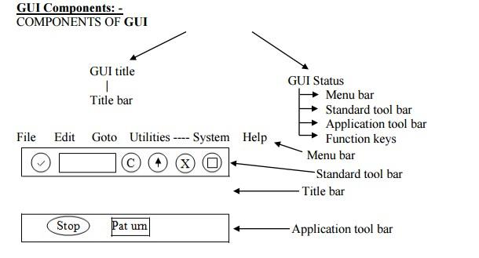
  + Each Screen has a GUI Status(es) which are independent components of a program.
  + This controls the Menu Bars, Standard Toolbar, and Application Toolbar with which the user can choose functions in the application.
  + We create them in the ABAP Workbench using the Menu Painter (**SE41**).
* **~~ABAP Program:~~**
  + ~~Each screen and GUI Status in the R/3 System belongs to one ABAP Program.~~
  + ~~The ABAP Program contains the dialog modules that are called by the Screen Flow Logic and also process the user input from the GUI Status or screen.~~
  + ~~ABAP Programs that use screens are also known as Dialog Programs.~~
* ***Dynpro:***
  + *A Screen together with its Flow Logic is called Dynpro (Dynamic Programming 🡪 since the screen flow logic influences the program flow) .*
  + *Each dynpro controls exactly one step of your Dialog Program.*
* ***ABAP Module Pool:***
  + *On a PBO or PAI event a Dynpro calls an ABAP dialog program. Collection of such programs is called the ABAP Module Pool.*
  + *All dynpros to be called from within one transaction refers to common module pool*.

**Properities/components of screen:**

* Attributes : provide general information of the screen such as screen description,pkg etc.
* Elements list : Provide the list of screen elements/compenets used in the screen such textbox,button,tables etc.
* Flow logic : To write the logic for the screen.

**Screen Painter (SE51):**

Used to design the custom screen layout in sap.

We can design the various layout elements through screen painter like - text field, input/output field , checkbox , push button , tabstrip with wizard , tablecontrol with wizard , subscreen area , custom control etc.

**OK codes in MPP:**

It captures the user actions (like button clicks) done in the screen means stores the function code of the button and handle them in Abap code. It carries func.code from screen to program.

Steps:

Define ok code in the screen - element list tab.

Then use it like case fun or if fun in the PAI module.

We can design the screen fields using the get_from_dictionary option also. Whatever the fields we selected will be the input fields for the screen.

**If not ok code, we can use sy-ucomm itself.**

**Menu Painter(SE41):**

Used to customize/design the GUI Status such menu bar (menu,goto…), std.toolbar(back,exit,cancel,find..) , Application toolbar(sort,print..) based on our req for our MPP.

We can use the same okcode define in the screen painter to add logic if some user actions happens.

**Communication b/w screen and prog:**

**We need to declare variable with the same field name which is maintained in the screen for inputs fiels,UI elements field etc**.

If user action needed, we define the function code in the screens. Then, Screen fun.code to be declared as a var in se38 of type sy-ucomm. Then we need to

To navigate to next screen , we need to write ‘CALL SCREEN <Screen_num>’.

**AT EXIT-COMMAND :**

It is a **special event** used in **Module Pool Programming** to handle exit-related function codes (like BACK, EXIT, CANCEL) **without triggering field validations**.

It ensures that the user can leave the screen without being blocked by input errors. It is used to come out of the screen even if the mandatory / required field is not filled.

**Why Use AT EXIT-COMMAND?**

1. **Bypasses Screen Validation** – Normally, pressing a button triggers the **PAI (Process After Input)** event, where all field validations (like mandatory fields) occur. If an error is found, SAP prevents the user from leaving.
   * AT EXIT-COMMAND allows users to **exit without triggering validation errors**.
2. **Used for Exit Buttons** – Commonly assigned to buttons like **Back, Exit, or Cancel** to allow smooth navigation.

Steps:

* Need to assign type ‘E’ for the exit/any button which is used to come out of the screen without considering mandatory fields in the screen painter.
* Create a module with the keyword ‘exit-command’ in the screen. Inside this module, add the code.

**CHAIN-ENDCHAIN :**

As sap default behaviour, if any input error occurs, it disabled all the input fields of the screen not the buttons.

This is kind of block, will help to decide which inputs fields are ready for input or not disabled even if any input error exist.

**This block has to be added in the flow logic of part.screen not inside the PAI or PBO module.**

Syntax: CHAIN.

FIELD: <field1, field2>.

MODULE <module name>.

ENDCHAIN.

**Types of Screens:**

**Normal Screen :**

Used for data entry, display.

**Sub-screen :**

Embedded the screen inside the main screen. In sub-screen, it is okay to use normal screen function code as well.

Steps:

1. Define the sub-screen space in the main screen through screen-painter.
2. Then create the layout for the sub-screens with the help of screen-painter.
3. In PBO of main screen,call the sub-screens into the sub-screen area of the normal screen using this syntax.(map the sub-screen area with sub-screen).

CALL Subscreen ‘subscreen area name’ including sy-repid sub-screen number.

1. To use the components/UI elements described in the Sub-screen, we need to use this syntax in the PAI in the normal screen.

Call subscreen <subscreen area name>.

Modal Dialog Box:

The screen appear as a dialog box like pop-up the message , confirmation msg and so on.

Independent okcode var,pai,pbo.

Move out options from screen:

* CALL SCREEN <scr_nr>– Keep the all the screen and current screen alive & move to next screen , use this. We also navigate back from the screen,it is possible.
* SET SCREEN <scr_nr> -Close all the prev. screen and current screen & move to next screen , use this. We also navigate back from the screen,it is not possible. To close the current screen SET SCREEN 0 then it automatically close to the previous screen. If no pre.screen, close the transaction.
* LEAVE TO SCREEN 0 - takes the user back to the last called screen.
* LEAVE PROGRAM - T**erminates the execution** of the current module pool program.

**TabStrip:**

* Display output/screen in the form of tabs.
* Each tabs generates/has a subscreen.
* Tab strip with wizard -> perform some pre-defined steps like giving prg_name,tabstrip name and so on which generates us the tab strip screen based on our info . Then it automatically generates the code.

**Table Control:**

* Display the data in the table format(Rows and cols).
* PBO Module -> We will used keep the data in the table format.
* LOOP AT Screen – mainly used to enable and disable the rows.

**Assignment on Module Pool Program:**

* Create a table with name z<yourid>_usr.
* There will be 2 fields in that table –
  + Z<yourid>_user
  + Z<yourid>_pass
* Field Name, Data Element Name and Domain Name all will be same
* Create TMG for this table and insert 5 Entries
* Create a Module Pool Program with 2 Screens – Program name: z<your id>_mpp1
  + Screen 1001
    - User Name
    - Password
    - Buttons
      * Submit
      * Cancel
    - GUI Status
      * EXIT
      * CANCEL
      * BACK
      * If any of the above GUI Status has been clicked use LEAVE PROGRAM
  + Check the User Id and Password combination, If its correct then CALL SCREEN 1002.
  + Screen 1002
    - 2 Input Box for inputting numbers
    - 1 Display only Box for Output
    - Buttons
      * Add
      * Sub
      * Div
      * Mul
  + Display the output based on the button selected / clicked
  + GUI Status for this screen needs to be created. If press on Back or Exit 🡪 CALL SCREEN 1001
  + If press on CANCEL 🡪 LEAVE PROGRAM

**Assignment on Module Pool Programming 2:**

* SFLIGHT and SCARR
* 1st Screen
  + User Id and Password 🡪 if login successful you will go to next screen else display message “Invalid user Id or password.” 🡪 Instead of Push Button 🡪 Icon in Application Tool Bar for Login 🡪 Clearing out the values you will give option in Application Tool Bar.
* 2nd Screen
  + Airline Code and Flight Date and click on Submit Push Button
* 3rd Screen
  + Table Control with all the fields of SFLIGHT Table 🡪 this will appear only if the values in Screen 2 is correct and we have some table values in sflight for the same.

**Object Oriented ABAP**

**What is Object Orientation?**

In the past, Information System used to be defined primarily by their functionality: Data and Functions were kept separate and linked together by means of input and output relations.

The Object-Oriented Approach, focuses on Objects that represent abstract or concrete things of the real world. These Objects are defined by their character and their properties, which are represented by their internal structure and their attribute (data). The behavior of these objects is described by the methods (functionality).

**Comparison between Procedural and Object Oriented Programming:**

* **Emphasis:**
  + Procedural Programming, Emphasis is on task
  + Object Oriented Programming, Emphasis is on things that does those task.
* **Modularization:**
  + Procedural Programming: Programs are divided into small programs 🡪 Function
  + Object Oriented Programming: Programs are organized into classes and objects and the functionalities are embedded into methods of a class.
* **Data Security:**
  + Procedural Programming: Most of the functions shares Global Data.
  + Object Oriented Programming: Data can be hidden and cannot be accessed by external sources.
* **Extensibility:**
  + Procedural Programming: Relatively more time consuming to modify any existing functionality.
  + Object Oriented Programming: New data and Functionalities can be easily added whenever necessary.

**Object Oriented Approach – Key Features**

* Better Programming Structure.
* Real world entity can be easily modeled.
* Stress on data security and data access.
* Reduction in Code Redundancy.
* Data Encapsulation and abstraction.

**What are Objects and Classes?**

**Objects:** An Object is a section of a source code that contains data and provided services. The data forms the attributes of the object and the Services are known as Methods (Operations or Functions). They form a capsule which combines the character to the respective behavior. Objects should enable programmers to map a real problem and its proposed software solution on a One-to-One basis.

**Classes:** Classes describe objects. From a technical point of view, Objects are the runtime instance of a class. In theory, we can create any number of objects based on a single class. Each instance (object) of a class has a unique identity and its own set of values for its attributes.

**Local and Global Class:** Class is an abstract description of an object. Class in ABAP Objects can be declared either locally or globally.

**Global Class:** Global Classes and Interfaces are defined in the Class Builder (Transaction Code SE24) in the ABAP Workbench. They are stored centrally in the class pools in the class library in the R/3 repository. All of the ABAP Programs in an R/3 system can access the global classes.

**Local Class:** Local Class are define in an ABAP Program (Transaction SE38) and can only be used in the program in which they are defined. Every class will have 2 Sections:

* **Definition:** This section is used to declare the components of the classes such as attributes, methods, events. They are enclosed in the ABAP Statement CLASS ….. ENDCLASS.

CLASS <name> DEFINITION.

ENDCLASS.

* **Implementation:** This section of a class contains the implementation of all Methods of the class. The implementation part of a local class is a processing block.

CLASS <name> IMPLEMENTATION.

ENDCLASS.

**Comparison between Local and Global Class:**

* **Accessed By:**
  + Global Class can be accesses by any program.
  + Local Class can only be accessed by the program inside which it has been defined.
* **Stored In:**
  + Global Class are stored in the Class Repository.
  + Local Class are stored in the program where it has been defined.
* **Created By:**
  + Global Class are created using Transaction SE24.
  + Local Class are created using Transaction SE38.
* **Namespace:**
  + Global Class must begin with either “Z” or “Y”.
  + Local Class can begin with any character.

**Structure of a Class:**

* A Class contains components
* Each component is assigned to a visibility section.
* Classes implement methods.

**Components of a Class:**

* **Attributes:** Any data, constants, types declared within a class form the attributes of the class.
* **Methods:** Block of code, providing some functionality offered by the class. Can be compared to Function Modules. They can access all of the attributes of a class. Methods are defined in the DEFINITION part of a class and implement in the IMPLEMENTATION part using the below processing block:

METHOD <name>.

………….

ENDMETHOD.

Methods are called using the CALL METHOD Statement.

* **Events:** A mechanism set within a class which can help a class to trigger methods of another/other class.
* **Interfaces:** Interfaces are independent structures that we can implement in a class to extend the scope of that class.

**Visibility of Components:**

Each Class component has a visibility. In ABAP Objects, the whole class definition is separated into three visibility sections:

* **PUBLIC:** Data declared in public section can be accessed by the class itself, by its subclasses as well as by other users outside the class.
* **PROTECTED:** Data declared in the protected section can be accessed by the class itself and also by its subclasses but not by external users outside the class.
* **PRIVATE:** Data declared in private section can be accessed by the class only, but not by its subclasses and by external users outside the class.

CLASS <name> DEFINITION.

PUBLIC SECTION.

. . . . .

PROTECTED SECTION.

. . . . .

PRIVATE SECTION.

. . . . .

ENDCLASS.

**Assignment for OO ABAP 1:** Create a program for arithmetic calculation from Object Oriented Approach. You will have 4 different methods for Addition, Subtraction, Multiplication and Division. Based on the radio button selection call the methods accordingly. Take 2 constants (lc_num1 value 100 and lc_num2 value 50) and 1 variable (lv_result) for the calculation.

**Assignment for OO ABAP 2:** Do the same program by using Parameters in the local class. Example given below

METHODS: add importing

num1 type i

num2 type i

exporting result type i.

CALL METHOD obj->add

EXPORTING

num1 = p_num1

num2 = p_num2

Importing

result = res.

**Assignment for OO ABAP 3:** Create a global class that will keep a track of your bank account. Then write a program to use this class. Below are the details:

* Class Name: ZCLACCOUNTxx 🡪 xx is your ID 🡪 if you id is 2 🡪 ZCLACCOUNT02
* Public Methods:
  + SET_BALANC (sets the balance to a new value)
    - Import Parameter
      * NEW_BALANCE type DMBTR
  + DEPOSIT (adds a deposit amount to the balance and returns the new balance)
    - Import Parameter
      * AMOUNT type DMBTR
    - Export Parameter
      * NEW_BALANCE
  + WITHDRAW (subtracts a deposit amount from the balance and returns the new balance)
    - Import Parameter
      * AMOUNT type DMBTR
    - Export Parameter
      * NEW_BALANCE type DMBTR
    - Exception
      * INSUFFICIENT_FUNDS
* Selection Screen
  + Parameters:
    - P_AMNT type DMBTR 🡪 set the balance (4000)
    - P_DPST 🡪 Deposit the amount (3000)
    - P_WDRW 🡪 Withdraw (200)
  + Output
    - Set Balance to 4,000.
    - Deposited 3,000 making New Balance as 7,000
    - Withdrew 200 making New Balance as 6,800
    - If we try to withdrew more than the actual balance we will get the Exception as Insufficient Funds

**Assignment for OO ABAP 4:** Create a global class which will display the Purchase and Sales Document related information as an Output. Appended are the details:

* Selection Screen
  + Radio Buttons
    - Purchase Information
      * Select Options
        + Purchasing Document
    - Sales Information
      * Select Options
        + Sales Document
* Based on user input extract Purchase Information by Joining EKKO and EKBE tables
* Based on user input extract Sales Information by Joining VBAK and VBAP tables.
* Global Class Design
  + Class Name 🡪 ZCLTABLExx 🡪 xx will be your ID
  + Methods
    - GET_PURCH and GET_SALES
* Display the result in ALV output

**Instance Attributes / Components:** Instance components exist separately in each instance (object) of the class and are referred using instance component selector **‘->’**. The instance attributes / components can be defined using normal ABAP Statements such as DATA, METHODS etc.

**Static Attributes / Components:** Static components only exists once per class and are valid for all the instances of the class. They are declared with the **CLASS-** Keyword. Static components can be used without even creating an instance of the class and are referred to using static component selector **‘=>’**.

**Attributes of Object Oriented Programming**

* **Inheritance:** Inheritance is the concept of adopting features from the parent and reusing them. It involves passing the behavior of a class to another class. You can use an existing class to derive a new class. Derived classes inherits the data and methods of the super class (parent class). However, they can overwrite existing methods and also add new ones.
  + **Types of Inheritance:**
  + **Single Inheritance:** Acquiring properties from Single parent.





* + - **Multi-level Inheritance:** Acquiring properties from multiple parents in terms of level / hierarchy.







* + - **Multiple Inheritance:** Acquiring properties from multiple parents







Syntax: CLASS parent DEFINITION.

…………

ENDCLASS.

CLASS child DEFINITION INHERITING FROM parent.

…………

ENDCLASS.

**Assignment for OO ABAP 5:** Create a program with following details:

* Classes:
  + Parent Class: lcl_inst_teacher
    - Methods:
      * constructor 🡪 increment the total number of teachers by 1
      * add_teacher 🡪 add a new teacher
      * display_teacher 🡪 displays all the teachers
      * display_total_teacher 🡪 displays total number of teachers
  + Child Class:
    - lcl_com_teach
      * Methods
        + Constructor with importing parameters
        + Add_teacher 🡪 redefine the super class method here by calculating the salary of a teacher based on total number of days * 8000.
    - lcl_art_teach 🡪 same as above
    - lcl_scn_teach 🡪 same as above
* Display the list of Arts, Commerce and Science Teachers separately with their salary in an ALV Format.
* Selection Screen
  + Radio Button
    - Commerce Teachers Information
    - Science Teachers Information
    - Art Teachers Information
* Add at least 10 teachers information for each department (science / art / commerce)
* Display only the details of those teacher whose radio button has been selected.
* Fields to be displayed: Teacher ID, First Name, Last Name, Salary, DOB and Contact.

**Assignment for OO ABAP 6:** Create a program with following details

* Selection Screen
  + Radio Button
    - Material Information
      * Select Options
        + MATNR
    - Sales Information
      * Select Options
        + VBELN
    - HR Information
      * Select Options
        + PERNR
* Radio Buttons will be present in 1 block and Select options will exist in another block.
* Create a local class to extract the information based on the radio button selected and the respective values inputted by user in SELECT-OPTIONS.
* Create 2 Custom Containers and display the outputs from 2 different tables for each radio button selection.
  + If Material is selected then
    - Custom Container 1 will show output from MARA
    - Custom Container 2 will show output from MARC
  + If Sales is selected then
    - Custom Container 1 will show output from VBAK
    - Custom Container 2 will show output from VBAP
  + If HR Information is selected then
    - Custom Container 1 will show output from PA0002
    - Custom Container 2 will show output from PA0001
  + Display 10 Fields from each table.
* **Abstraction:** Everything is visualized in terms of classes and objects.
* **Encapsulation:** The wrapping up of data and methods into a single unit (called Class) is known as Encapsulation. The data is not accessible to the outside world only those methods, which are wrapped in the class can access it.
* **Polymorphism:** Methods of same name behave differently in different classes (Identically names methods behave differently in different classes).

**Super:** Super is a key word used to represent the super class of a class. In OOPS you can access the methods and attributes of the super class using the word SUPER.

**Assignment for OO ABAP 7:** Create a program with following details

* Selection Screen
  + Radio Button
    - Material Information
      * Parameter
        + MATNR
    - Purchase Information
      * Parameter
        + EBELN
    - HR Information
      * Parameter
        + PERNR
* Radio Buttons will be present in 1 block and Select options will exist in another block.
* Create a Global class to extract the information based on the radio button selected and the respective values inputted by user in PARAMETER.
  + Parent Class will only give you details for MARA, EKKO and PA0000.
  + Sub Class will redefine all these methods and will give you the above data as well as data from MARC, EKBE and PA0002.
* Create 2 Custom Containers and display the outputs from 2 different tables for each radio button selection.
  + If Material is selected then
    - Custom Container 1 will show output from MARA
    - Custom Container 2 will show output from MARC
  + If Purchase is selected then
    - Custom Container 1 will show output from VBAK
    - Custom Container 2 will show output from VBAP
  + If HR Information is selected then
    - Custom Container 1 will show output from PA0000
    - Custom Container 2 will show output from PA0002
  + Display 10 Fields from each table.

**Field Symbols:**

Field symbol is a placeholder for data object which points to the value present at the memory address of a data object. Whenever we declare any field symbol, it doesn’t reserve any physical memory space. It only points to the data object at runtime.

**Types of Field Symbols:**

* **Typed Field Symbol**
  + Typed field symbols can point to the data object of specified type only.
  + After assigning a data object to a field symbol, if we make any changes to the field symbol value then the value of corresponding data object is also updated.
  + They can be declared as ---

DATA: var type I value 2.

FIELD-SYMBOL: <fs_var> type i.

ASSIGN var to <fs_var>.

WRITE:/ <fs_var>.

* + If we change any field of structure in field symbol, the corresponding field in an internal table will get updated. We don’t need to write MODIFY Statement which we would have written if we had used work area. This is because work area stores a copy of the internal table row, whereas field symbol directly references the internal table row. Hence, processing of internal table with field symbol is faster than the processing of internal table with work area.
  + Always perform a check on field symbol that if it is assigned before doing any operation to avoid short dump.
  + Also, after doing the operation, unassign the field symbol.
* **Generic Field Symbol:**
  + Dynamic Programming is actually implemented using Generic Field Symbols. The most commonly used generic types are TYPE ANY and TYPE ANY TABLE. Here, we can assign any data object to TYPE ANY filed symbol whereas TYPE ANY TABLE field symbol is used for assigning any internal table.

FIELD-SYMBOLS: <fs_str> TYPE ANY,  
 <fs_data> TYPE ANY.  
  
DATA: lw_mara TYPE mara.  
ASSIGN lw_mara to <fs_str>. *"lw_mara-matnr | <fs_mara>-matnr.*  
IF <fs_str> IS ASSIGNED.  
 ASSIGN COMPONENT 'MATNR' OF STRUCTURE <fs_str> TO <fs_data>.  
 IF <fs_data> IS ASSIGNED.  
 <fs_data> = 'Piyush Bagri'.  
 UNASSIGN <fs_data>.  
 ENDIF.  
 UNASSIGN <fs_str>.  
ENDIF.

* + After assigning lw_mara to <fs_str>, we cannot directly use “-“ operator on field symbol to access the fields of mara structure (<fs_mara>-matnr would produce syntax error). This is because the field symbol type is declared only at runtime and not at compile time.
  + So to access the MATNR field with field symbol, first we need to assign that field symbol component to a different field symbol and then use the new field symbol to update the MATNR field (shown in above code).

**Assignment for OO ABAP 8:** Create a program with below details

* Selection Screen
  + Parameters
    - Table Name
    - No. of Rows
* Validation
  + The table name which has been input by user in selection screen – it should be a correct table name. To validate the same use table DD02l
  + No. of Rows should not be more than 10,000.
* Extraction Logic
  + If table exists in database then by using CREATE DATA Statement create the data object and assign the reference to data object reference variable. (EX: CREATE DATA lw_tab TYPE STANDARD TABLE OF <xyz>.)
  + Select all the fields from that table with No. of rows (inputted in the selection screen) and display it in the ALV.
  + Create the field catalog by using Function Module REUSE_ALV_FIELDCATALOG_MERGE
  + Display the ALV.

**Assignment for OO ABAP 9:** Create Global classes with below details

* 1 Super Class and 2 Sub Classes
* Methods
  + Get_data
  + Display_data
* If you have selected Super Class then extract the data from MARA Table up to 25 rows.
* If you have selected Sub Class1 then extract the distinct 25 Materials from MARA and extract details of those 25 materials from MARC.
* If you have selected Sub Class2 then extract the distinct 25 Materials from MARA and extract details of those 25 materials from MARD.
* Display the data.
* Selection Screen
  + Radio Buttons:
    - Super Class Information
    - Sub Class 1 Information
    - Sub Class 2 Information

**File Handling Techniques:**

* These techniques are used to upload or download the data from or into the specified file path from Legacy System into an Internal Table of the programs.
* There are 2 types of file handling techniques:
  + **Front End System / Local PC:**
    - **Upload:** The SAP system provides standard Function Modules GUI_UPLOAD or WS_UPLOAD to upload the data from the specified path of local pc / presentation server into an internal table of the program.
    - **Download:** The standard Function Module GUI_DOWNLOAD or WS_DOWNLOAD is used to download the data from an internal table into the specified path of the Front End System / Local PC / Presentation Server.
    - **Files from Local PC can’t be processed in background since Standard Function Module give runtime errors.**
    - **F4_FILENAME:** This Function Module is used to provide the search help to select the required path of the Front End System / Local PC / Presentation Server.

Example: AT SELECTION SCREEN ON VALUE-REQUEST <p_file>

CALL FUNCTION ‘F4_FILENAME’

EXPORTING

Program_name = sy-repid

Dynpro_Number = sy-dynnr

Field_name = <p_file> 🡪 Only in Uppercase

IMPORTING

File_name = <p_file>

Here, <p_file> is a parameter to enter file path.

**Move-Corresponding and into Corresponding Statements:**

* This Statement is used to move corresponding field data from the source to the destination work areas or field symbols and internal tables.
* MOVE-CORRESPONDING <WA_SOURCE> TO <WA_DESTINATION>
* Select <f1> <f2> …. INTO CORRESPONDING FIELDS OF TABLE <git_itab>
  + **Application System – AL11:**
    - It is used to maintain files securely.
    - The transaction code AL11 is used to work with Application Server.
    - It can be used to handle files in background.
    - **Download / Transfer:** Below ABAP Statements are used to transfer the data from an Internal Table into the specified path of Application Server (AL11)
      * OPEN DATASET …… FOR OUTPUT
        + This statement is used to open the required files in WRITE Mode in Application Server
        + ***OPEN DATASET <p_file> FOR OUTPUT IN TEXT/BINARY MODE ENCODING DEFAULT.***
      * TRANSFER ….TO
        + This statement is used to transfer the concatenated data (String Line) into the opened file.

LOOP AT GIT_FINAL into GWA_FINAL.

<gv_char> = <gv_number> “Convert Number type to Character Type

WRITE gwa_final-currency to gv_amount_c “Converting Currency to Char

TRANSFER <gv_line> to <p_file?

Clear <gv_line>

ENDLOOP.

* + - * CLOSED DATASET ……
        + It is used to close the opened file in the server.
    - **Upload:** Below ABAP Statements are used to transfer the data from the specified path of Application Server (AL11) to an Internal Table
      * OPEN DATASET…FOR INPUT
        + This statement is used to open the file in Read Mode.

OPEN DATASET <p_file> FOR INPUT IN TEXT/BINARY MODE ENCODING DEFAULT.

* + - * READ DATASET
        + This statement is used to read the file from Application Server to Internal Table. This statement read the file record by record.

DO

READ DATASET <p_file> into <wa_final>

If sy-subrc is initial

APPEND <wa_final> to <it_fina>

ELSE

EXIT

ENDIF.

Clear <wa_final>

ENDDO.

* + - * CLOSE DATASET

**Assignment on File Handling Technique 1:** Below are the program details

* Selection Screen
  + Radio Buttons 🡪 Block 1 🡪 Title 🡪 Selection Condition
    - Vendor Master Information
      * Select Options: Vendor 🡪 Block 2
    - Customer Master Information
      * Select Options: Customer 🡪 Block 2
  + Radio Buttons
    - File Download 🡪 Block 3 🡪 Title 🡪 Display Category
    - List View 🡪 Block 3
    - Classical View 🡪 Block 3
  + Parameter: File Name and File Path 🡪 Block 3
  + Select Options will be visible based on the Radio Button Selection
  + Create Global Class to extract the data and download the file to Application Server.
  + Proper validation should be in place for Vendor and Customer.
  + For Vendor Master Take 10 Fields each from LFA1 and LFB1 Tables. Join the tables and prepare the final output.
  + For Customer Master take 10 fields each from KNA1 and KNB1 Tables. Join the tables and prepare the final output.
  + File Name Parameter will only appear when File Download Radio Button is selected
  + If List View is selected then show the final output as ALV
  + If Classical View is selected then display the final output in classical.

**Assignment on File Handling Technique 2:** Below are the program details

* Selection Screen
  + - Select Options 🡪 Block 1
      * Range Object Name
      * Number Range Number
    - Parameter 🡪 Block 2
      * Residual Percentage
    - Display Option 🡪 Block 3
      * ALV Display
      * File
        + Application Server

File Path

File Name

* + - * + Presentation Server

File Path

File Name

* Data Extraction and all the logics will be available from NRIV and TNRO Tables respectively.
* Provide F4 help for file paths
* Fields to be displayed
  + Object Name
  + Object Description
  + Sub Object Value
  + Range Number
  + Fiscal Year
  + Lower Limit
  + Upper Limit
  + Current Value
  + Residual Percentage
* You need to display all Number Ranges which are Less than or Equals to the percentage provided in the selection screen.
* Validations
  + Validate whether the entered Object Name exits or not
  + Validates whether the entered Range Number exists or not
  + Residual Percentage: if from number and to number fields contains character or any special characters then number range will not be calculated. Range will only be calculated only if the from and to are in numbers.

**Legacy System Migration Workbench (LSMW)**

The LSMW is a tool based on SAP Software that supports single or periodic data transfer from Legacy/Non-SAP to SAP Systems (and with restriction from SAP to SAP System). Its core functions are:

* Importing legacy data from PC Spreadsheet tables or sequential files.
* Converting data from its original (Legacy) format to the target (SAP) format.
* Importing the data using the standard interfaces of SAP (IDoc Inbound Processing, Batch Input, Direct Input etc.)

**Steps to create LSMW:**

1. **Creating Project, Subproject and Object:** For using LSMW Tool, first step is to create Project, Subproject and Object. Here, project can have multiple subprojects and in turn subprojects can have multiple objects.
   1. **Create Project:** Give the desired name of Data Migration Project for the module (EX: ZPM)
   2. **Create Subproject:** Give the desired name of Data Migration Subproject (EX: EQUIPMENT)
   3. **Create Object:** Give the desired name of Data Migration Object (Ex: CREATE)
2. **Selecting Menu Items:** Once project, subproject and objects are created, pressing enter would generate the screen which includes all the Menu Items.
3. **Main Object Attributes:** This will define the procedure we adopt for our program, which could be
   1. **Standard Batch / Direct Input**
   2. **Batch Recording**
   3. **Business Object Method (BAPI)**
   4. **IDoc (Intermediate Document)**
4. **Object Overview and Field List:** Before moving to the second menu item “Maintain Source Structure”, we would go for listing the fields and viewing the structuring of the fields by pressing the OBJECT OVERVIEW button.
5. **Maintain Source Structures:** Source Structure will have all the fields which are recorded or captured during method definition.
6. **Maintain Source Fields:** Source fields are same which we have listed in Step 4.
7. **Maintain Structure Relations:** This step is for maintaining relation between structure and recording / standard program.
8. **Maintain Field Mapping and Conversion Rules:** We have created the structure to program relationship, now we have to create the mapping (relationship) between fields from structure and fields from program / recording.
9. **Specify Files:** Before performing this step, you need to create the file format with exact field sequence. Double Click on “SPECIFY FILES” in the Menu List Screen which will guide you to source of the file.
10. **Assign Files:**
11. **Read Data:**
12. **Display Read Data**
13. **Convert Data**
14. **Display Converted Data**
15. **Create Batch Input Session**

**SAP Notes :**

Yog can download it from the below link :

* <https://drive.google.com/file/d/1wggauvSf4fcM0zo-X0P_JHnM7rLxIkhq/view?usp=sharing>

*From <*[*https://www.youtube.com/watch?v=QK0rXdV_N1c&list=PLueNE-YFSVFhEnWb0DFfxWGF0i4de9AZn&index=8*](https://www.youtube.com/watch?v=QK0rXdV_N1c&list=PLueNE-YFSVFhEnWb0DFfxWGF0i4de9AZn&index=8)*>*

* <https://blogs.sap.com/2015/04/21/how-to-analyze-performance-problem/> - Performance analysis.
* Abap Basic Concept : <https://www.elearningsolutions.co.in/basic-concepts-of-sap-abap/>.

ABAP (Advanced Business Application Programming) is a programming language for developing applications for the SAP R/3 system, a widely installed business application subsystem. The latest version, ABAP Objects, is object-oriented programming. SAP will run applications written using ABAP/4, the earlier ABAP version, as well as applications using ABAP Objects.

Here we are having RICEF's concepts.

R- Reports

I - Interfaces

C-Conversions

E- Enhancements

F- Forms.

Reports: Classical & ALV reports, OOALV , Dialog & OO programming, Module Pool Programming

Enhancements: Modifications, User exits , Customer Exits, BADI's , BTE's , Enhancement Framework.

Conversions: BDCs , LSMW, Extractions , Excel downloads, Email/PDF features etc

Interface: BAPI , ALE -IDoc / EDI, Workflow

Forms: SAP Scripts, Smartforms , Jetforms , Adobe Forms

These all the topics comes under ABAP. These Portal and BSP's comes under Netweaver web technologies known as Web dynpro ABAP where you can built those applications using ABAP.

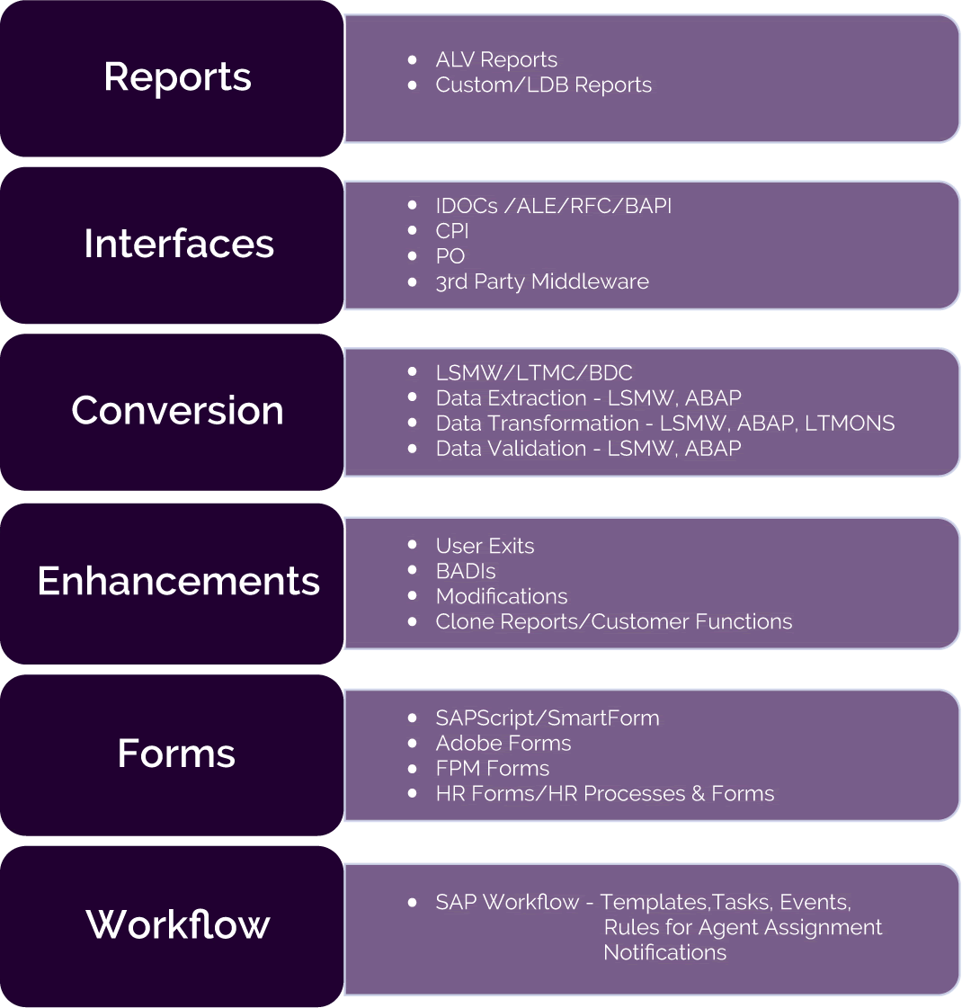

Interface:

Interfaces are used to exchange data between the SAP system and external systems or between different SAP systems. Interface development involves defining the structure and format of data transfer.

It handle the intricate data exchanges between SAP and other external systems. Depending on the direction of data flow, interfaces can be classified as inbound (data entering SAP) or outbound (data leaving SAP).

/

* RFC – Remote Function Call.
* BAPI – Business Application Prog Interface.
* ALE/IDOC – Application Link Enabling/Intermediate document data.

Remote Function Call (RFC):

RFC is a protocol and a mechanism used for communication between different SAP systems or between SAP systems and external systems.

It allows one SAP system to call functions (**function modules**) in another SAP system or even in non-SAP systems, enabling real-time data exchange and interaction. To get data from one SAP system to another /external system -> we need to create RFC. Mostly used for communication between sap to sap system.

RFC tcode – SM59 table : RFC

Configuration:

Create an RFC Destination:

- In your local SAP system, you need to define an RFC destination to the remote system where the function module is located. This can be done through transaction SM59 (RFC Destinations).

- Tech.settings-> we need to give ip server and instance no of a target system and save it as ip address/host.

- Logon.security->username ,client and password.

- CALL FUNCTION 'Z_GET_CUSTOMER_DETAILS' "Replace with the actual RFC FM name created in target system”

DESTINATION destination(destination name given in the RFC configuration(SM59))

In source system -> we need to call the FM created in target system with the keyword **destination.**

In target system -> need to create FM ->Remote enable module , Pass by value choose.

Types:

Synchronous RFC: The client(source) and server(target) system both should be available at the time of execution of data transfer. Like the phone call.

Asynchronous RFC: The client(source) and server(target) system should not be available at the time of execution of data transfer & the result will not be immediately required to sent back to the calling system. Like the sending message to the X.

Transactional RFC:

Queued RFC:

~~ALE(Application Link Enabling) :~~

~~IT is a technology ->communicate b/w SAP servers.~~

~~Data is transferred in a form of a document called IDOC.~~

Data Transfer:

Sap to Sap(ALE -> IDOC):

Sender system: Outbound program -> Data select the DB -> Generates IDOC->Distribute module.

Receiver system: Inbound Program -> Incoming idoc Data -> Update in DB

sap to sap scenario->Abap consultant role is both the side sender and receiver

SAP to NON-SAP :

EDI(Electronic Data Interchange) -> technology to communicate b/w SAP to NON-SAP.

Sender system: Outbound program -> Data select the DB -> Generates IDOC->Distribute

Middleware(TIBICO/PI/XI) : Idoc to XML -> given to middleware S/W which convert data into format which can be understood by the receiver system.

Receiver system: Inbound Program -> Incoming idoc Data -> Update in DB

IDOC(Intermediate Data):

https://www.youtube.com/watch?v=vlvadnmRsZg&list=PLl_MEz33D2N1dPXYiaf-6JZF5c97S7vWU&index=3

* It is a data container which is used to transfer data from SAP -> NON-SAP / SAP->SAP. Multiple receiver(target system) can be there for one server(sender system).
* Configure the path where the idoc needs to be send.
* What type of data is transferred:

Following type of data is transferred using Idoc container :

1. Master Data : Material Master, Vendor master, Customer master etc.

2. Transaction Data: Purchase order, sales order, Fl document,Invoice,Delivery details etc.

3. Custom field data: Custom fields data with idoc extension concept.

Idoc Configuration/Components :

Segments(Structure : bcoz it consists of fields) - Collection of fields, Transaction Code - WE31 ->Customer segments(Z_) and standard segments(E_)

Message Type – Tells for what business transaction the idoc is used.It tell the purpose of the idoc. For example, is this form used to place an order, to confirm an order, or to invoice someone? So, even if the form (Basic Type) looks the same, the purpose (Message Type) can be different.

Idoc Type – Define the structure or layout of the form(IDoc). It tells you what information goes where on the idoc. For example, a Basic Type for a purchase order will have spaces for the order number, item details, quantities, prices, etc.

Idoc type message Type - WE82

Create logical system - Sale/BD54

Assign logical system to client - Sale/SCC4

Classfication:

Inbound IDOC ->Data is coming to SAP(2)

Outbounf IDOC -> Data is going from SAP(1).

Idoc Structure :

- Control record -> hold the administrative information about idoc like idoc number,sender and receiver information etc. Table : EDIDC

- Data record -> Holds the data which is transferred/going to transfer in the form of segments. Table : EDID4.

- Status record-> Holds thee status of an IDOC. Table : EDIDS.

Inbound idoc – value ranges between 50 to 75

Outbound idoc - value ranges between 01 to 49

IDOC type (tcode WE30) – collection of segments(structure) – each segments is a collection of fields.

Message type(Tcode WE81) – gives what of type of data is stored in the IDOC like purchase order data/ customer data etc..

Ex: Matmas - Material master

Debmas - Customer master

Cremas - Vendor master

Orders - Purchase order etc.,.

DELFOR – Delivery document

INVOIC – Invoice.

Logical System(Tcode BD54/SALE) -> unique name assigned to each server and client for identification purpose.

RFC Connection:

RFC Port :

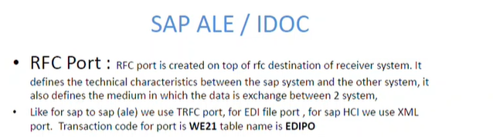

Partner Profile:

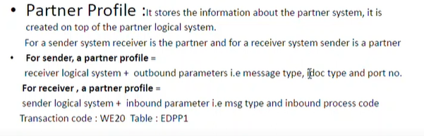

Idoc monitoring – we09/we02

Idoc re-process – BD87

Idoc processing – WE19

Process:

<https://www.youtube.com/watch?v=GTZSofDegcI&list=PLmajIBPiks12rUEXT7h-BN6oYf4txfPhT&index=3>

https://www.youtube.com/watch?v=ciTT9BhQ-TA&list=PLmajIBPiks12rUEXT7h-BN6oYf4txfPhT&index=1

Create segment(we31) ->create idoc type(we30)->create message type(we81)->create link b/w idoc and msg type(we82).

* + 1. Create logical system
    2. RFC connection
    3. Create port and assign it to RFC connection.
    4. Create partner profile – configure everything like direction and distribute the model.

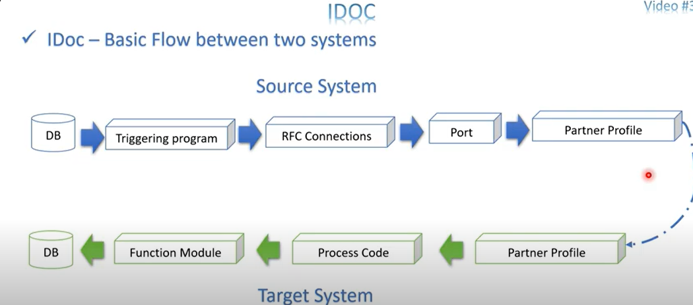

**BAPI(Business Programming Application Interface):**

**Interface & Conversion**.

* + Implemented as a FM.
  + Here, we will use RFC concepts also – [ [ [FM] Remote enable FM ] -BAPI].
  + When we are working related to Business process/functions like SO creation , Delivery creation ,PO creation /updation/anything we are doing business -> we will use BAPI.
  + Business function/process -> Reading data , create & updating data and Mass uploading.

**What is BAPI?**

* + **BAPIs are standardized programming interfaces (methods) that allow external applications to access business processes and data within the SAP R/3 System**.
  + They provide stable and standardized methods for seamless integration between SAP systems and external applications, legacy systems, and add-ons.
  + **BAPIs are defined in the Business Object Repository (BOR) as methods associated with specific SAP business object types.**
  + **These methods are implemented as RFC-enabled function modules in the ABAP Workbench**.
* BAPIs are typically used for creating, reading, updating, or deleting data in SAP.

Creating a BAPI:

* + To create a BAPI, follow these steps:
  + Go to transaction swo1 (Tools → Business Framework → BAPI Development → Business Object Builder).
  + Select the relevant business object based on your functional requirement.
  + Open the business object in change mode.
  + Add a new method by selecting Utilities → API Methods → Add method.
  + Specify the method name, description, and other relevant details.
  + Create the method.
  + After generating and executing the program, your BAPI is ready.

Testing and Releasing:

* + You can test the BAPI by using the Business Object Builder or transaction code SWUD.
  + To release the BAPI, first release the corresponding function module (using transaction SE37).
  + Set the status of the method to ‘released’ in the Business Object Builder (transaction SWO1).

BOR 

Business obj type/Name(like BUS*) – like class.

Methods associated with (BAPI – API functions)

* Relevant functions modules gathered under on fun.group.
* Under BOR -> we have multiple business obj.type like sales,delivery ->under part.business obj type we have relevant methods(functionality).
* BAPI FM – needs return parameter – keep the parameter name as ‘return’.
* No direct call -> call business obj and call the relevant method and use it.
* BAPI = FM + Business.obj

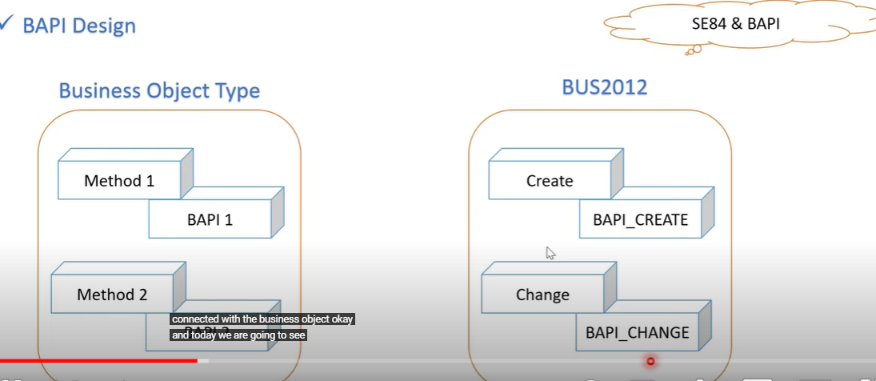

<https://sapcodes.com/2015/11/19/bapi-an-introduction/>

Tcode : SE84(display BAPI ) , SW01(Bapi creation)

**BAPI Testing:**

Static method – call method using class name.

BAPI Test -> se84 -Business obj name 

Instance method -need to create obj(parameter pass means constructor with parameter) and call method.

**BAPI Creation:** <https://www.youtube.com/watch?v=Oa20wgPNpz8&list=PLmajIBPiks12Ft83BXiFG9g7vu2EtvSwz&index=2>

BAPI Vs BDC :

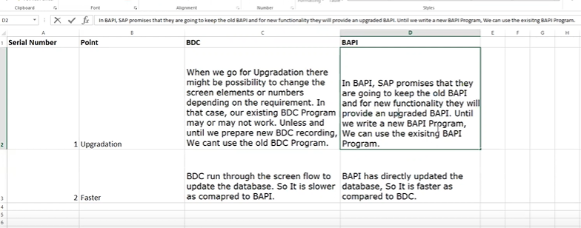

**Difference b/w BAPI and RFC:**

Purpose:

BAPIs are specialized RFC-enabled function modules designed for specific business scenarios.

RFCs can be used for various purposes, including executing custom functions, calling standard SAP functions, or exchanging data between systems.

Scope:

BAPI: BAPIs are a subset of RFCs. They are specifically tailored for business-related operations within the SAP system. BAPIs are usually predefined by SAP and provide a standardized and controlled way to access and manipulate SAP data and processes.

RFC: RFC is a more general term that encompasses a wider range of remote function calls. RFCs can be used for a variety of purposes, including custom development, system-to-system communication, and more. While BAPIs are a specific type of RFC, there are also other types of RFCs like Remote-Enabled Function Modules and Type T (Transactional RFC) used for different scenarios.

Usage:

BAPI: BAPIs are primarily used for integrating external systems with SAP and for executing specific business processes within SAP, such as creating orders, retrieving customer information, or posting goods movements.

RFC: RFCs can be used for a broader set of purposes, including custom development and system-to-system communication, and they are not limited to just business processes. You can create your custom RFCs for various tasks within an SAP system or between SAP systems.

Standardization and Documentation:

BAPI: BAPIs are typically well-documented and standardized by SAP. They provide clear interfaces and parameter structures, making them easier to use for integration. This standardization helps ensure consistency and compatibility when integrating external systems with SAP.

RFC: While RFCs can also be documented, their usage can vary widely because they are more general in nature. Custom RFCs may not have the same level of standardization and documentation as BAPIs.

In summary, BAPIs are a specific type of RFC designed for integrating external applications with SAP systems by exposing SAP business processes.

RFC, on the other hand, is a broader term encompassing various remote function call mechanisms used in SAP for a wide range of purposes, including both business-related operations and custom development.

BAPIs are often the preferred choice when integrating external systems with SAP for business process automation due to their standardized and well-documented nature.

**Steps:**

1. Create the program.
   1. Get the data from the file.
   2. Loop the internal table data and call the FM to excute the particular task given/needed by the business.
   3. When calling the FM, we must pass the parameters which are given in the file to do the part.task.
   4. Return table to be created which stores the successful/error message.

**SAP Externsion BAPI :**

Adding custom fields to the standard Bapi.

**BAPI in 3rd party system : https://chatgpt.com/c/05a1e165-d93d-4bbd-9e92-19cca022d5a5**

**Data Migration (CONVERSIONS):**

Migrate the data from legacy system (non-sap system) into Sap system.

Steps in data Migration:

1. Extracting the data – Extract the data from the non-sap system into a file.
2. Converting the data – Convert the data into an appropriate format. This is called **Data conversion.**
3. Importing the data – Import the data into a SAP System.
4. Verify the data – Check the accuracy of data in Sap System.

Data Migration Techniques:

1.BDC (Batch Data Communication)

2.LSMW

3.BAPI(taken notes on interface)

Conversion : To upload the data into SAP system from non-sap system -> we need to convert the data from one form to another form which is support by the legacy system (Non-sap system). This is called Conversions/Data Transfer.

BDC(Batch Data Communication) : (upload the data into SAP by converting the non-sap data format into sap data format)

* It is a technique using with legacy data or data loading into SAP system which is not updated in the SAP systems.
* BDC was a great way of uploading data into SAP in a pre-BAPI era, now SAP is making available BAPIs for most of the functionalities, someone should first look out for BAPI if it is not available then go for BDC.
* Works by **principle of screen recording** -> record the steps and use that record to upload / migrate the data into SAP.
* Tcode – SHDB.

Common Steps:

1. Record the steps in the SHDB.
2. Pass the record to the program means create a program which consists of the above recording – SHDB tcode(generate the prog).
3. Customize the generated program such as:
   1. Upload the file in the program into the table.
   2. Read the data from the file into another table if some condition is there.
   3. Call the recording inside the table loop. Now we use **call transaction or session method.**

Types of uploading data:

https://sapsearch.wordpress.com/bdc-using-call-transaction-method/

1.Call transaction method : (through tcode - update the data to the sap)

* + By calling the transaction using **CALL TRANSACTION using internal table(bdcdata table** -where all data related to one record will be stored as table).
  + Upload the data from flat file(excel/text file) to sap by calling transaction through a series of seq of steps.
  + Less data upload.
  + DB update immediately.
  + Example:
    - **CALL TRANSACTION ‘MM01’ USING LT_BDCDATA MODE ‘A/E/N/’ UPDATE ‘A/S’ MESSAGE INTO LT_MESSTAB.**

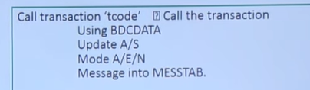

**BDC DATA :**

Simply,It holds all the screens and fields related info -> to be transferred into corresponding SAP Transaction.

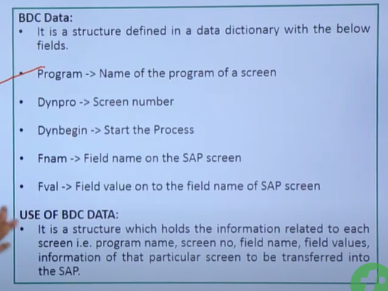

**BDC Update Mode:**

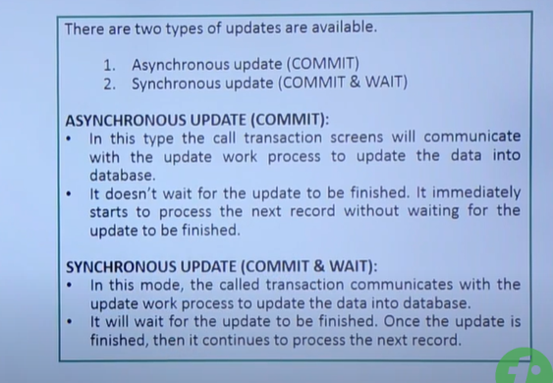

**BDC Processing mode :**

1. A – All screen mode -> Will show screen by screen processing.
2. E – Error screen ->Error in BDC - show the screen where the error comes.
3. N – No screen -> No screen will be displayed , we will directly get the output.

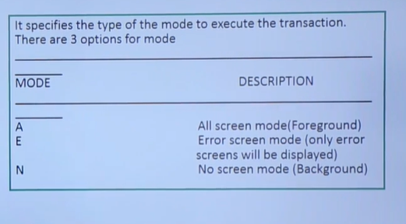

BDC Message:

This is for the error handling for each record we called in the transaction.

Summary: record the transaction by manually entering the data to create the dummy structure of BDC data.Then, it will create program and pass the input file to the program to upload the data in SAP.

1. Session Method:

https://sinuabaptutor.blogspot.com/2017/06/tutorial-on-bdc-session-method-sap-abap.html

* Upload the large amt of data into SAP.
* It consists of a grp of records which have to transferred to SAP.
* Through FM , we will upload the data in SAP.

Step: Create the session and process it in the generated program.

* FM is there to create a session, upload the data in session and close the session.
  + FM ->BDC_OPEN_GROUP , BDC_INSERT , BDC_CLOSE_GROUP.

1. **BDC_OPEN_GROUP**-> create this FM to open/create the session. Parameters -> give the group/session name , keep and user data.

Keep parameters-> Indicator to keep the processed session in SM35.

Holddate -> Lock the session until this date.

1. **BDC_INSERT** -> pass the tcode to be used and bdc data to be updated as a parameter inside the BDC_CREATE_Group FM.
2. **BDC_CLOSE_GROUP** -> Close the session/group.
3. Excute the program to create the session.
4. Next to process the session/record by sm35 tcode.

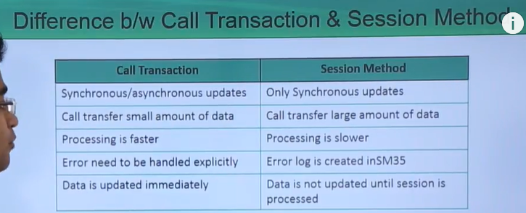

DIRECT INPUT METHOD:

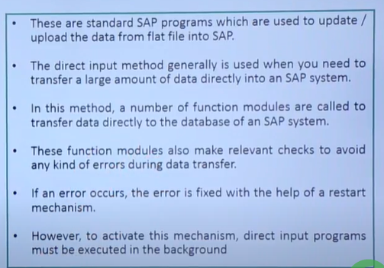

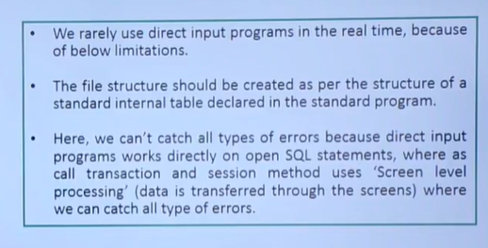

The Direct Input method is another technique for data migration in SAP. It is particularly efficient for large volumes of data, as it bypasses the normal transaction screens and writes data directly into the SAP database tables. This method is faster than BDC because it reduces the overhead associated with screen navigation and user interface processing.

**Key Characteristics of Direct Input**

* Efficiency: Suitable for high-volume data loads as it writes directly to database tables.
* Speed: Faster than BDC since it skips the user interface.
* Use Cases: Typically used for initial data migration or bulk data updates.

**Steps to Use Direct Input Method:**

* Identify the Direct Input Program:
* SAP provides standard direct input programs for various types of data (e.g., material master, vendor master). These programs are generally available in transaction SCC1.
* Prepare Data Files:
  + Prepare the data files in the required format. These are usually flat files (e.g., CSV or text files) containing the data to be uploaded.
  + Ensure the data is clean, validated, and formatted correctly according to the requirements of the direct input program.

**Transfer Data Files:**

* Transfer the data files to the SAP application server. This can be done using transaction CG3Z for upload or via FTP/SFTP.

**Execute Direct Input Program:**

* Execute the relevant direct input program to load the data. This can be done using transaction SCC1 or the relevant transaction for the specific direct input program.

The program will read the data from the file and directly update the SAP database tables.

LSMW(LEGACY System Migration Workbench):

* LSMW is a tool that supports the transfer of data from non-SAP systems (“Legacy Systems”) to SAP R/3 systems. This can be a one-time transfer as well as a periodic one.
* LSMW also supports conversion of data of the legacy system in a numerous way.
* The data can then be imported into the SAP R/3 system via batch input recording, direct input, BAPIs or IDocs.
* Works well for the master data upload.
* Can import and export LSMW.

The main functions of the LSM Workbench are:

1. Import data (legacy data in spreadsheet tables and/or sequential files)
2. Convert data (from source format to target format)
3. Import data (into the database of the R/3 application)

**Project** -> Data transfer project. It can have multiple subprojects.

Subproject -> Name of the subproject. It can have multiple objects.

Object -> Corresponds to the business object like create, update the business object like material master data.

LSMW Steps:

1. Choose the methods to migrate the data in LSMW.

4 methods – Direct input method, Batch Input Recording, BAPI , IDOC

1. Give a source structure name for the data.
2. Define fields in the source structure means define the columns given in the source file in the same order itself. Through create structure in se11 and copy the created structure into this LSMW.
3. Map the recording and the source structure means passing the legacy data into the recording.

If single source structure -> default SAP map the recording & source structure.

If we have multiple source structures then we click the relationship button and give the structure to bind it.

1. Field by field mapping -> map the legacy/source data field to the corresponding recording data field ().
2. Define translation, fixed value or user routine – use this.
3. Specify Legacy files to be import into LSMW.
4. Assign the files to the source structure.
5. Read the files and it stores in the application server.
6. Display the read data/file data.
7. Convert the legacy data into sap format & store it in application server.
8. Create batch input session to process the data in a file as per the recording .

**SAP ENHANCEMENTS & MODIFICATIONS:**

* SAP -> provided standard solution->if we alter existing functionality or add new functionality to the SAP std solution based on customer needs.
* It is a concept of adding our own functionality to the sap business application without modifying the logic/code of the original applications.
* **Modification (**SAP namespace **-** reserved for SAP’s own standard objects**)**: This refers to enhancing or changing the functionality of standard SAP objects without using custom naming conventions. These changes are applied directly to SAP’s standard code (which does not start with "Z" or "Y"). Such modifications are often discouraged because they might be overwritten during system upgrades or patches. Directly change the sap std functionality/direct impact.
* **Enhancement (Customer namespace)**: Enhancements refer to adding functionality within the customer-specific namespace. Names of such enhancements typically start with "Z" or "Y", indicating custom development created by the customer or developer. Enhancements allow modifications to standard SAP functionality in a controlled manner, which can be easily maintained and upgraded without affecting standard SAP code directly.

Types:

Enhancement: (We will add new functionality without disturbing the original code/function)

* Implicit and Explicit implicit Enhancement.
* Customer Exit (FM Exit , Screen Exit . Menu Exit).
* BADI.

Modification: (Directly change the sap std functionality/direct impact)

* User Exits.

**Implicit Enhancement:**

Implicit enhancement in SAP ABAP is a technique that allows you to modify standard SAP code without changing the original code. SAP provides predefined enhancement spots where you can add your custom code. These spots are already included in the SAP standard programs, and you can hook your code into them when necessary.

* -It is available at the start & end of the selected development objects(program) – implicit points(pre-defined by SAP).
* Can be programs, Subroutine or FM.
* Create implicit implementation (Write the logic) using those points.
* Does not require enh.spots.
* Declaration & code implementation.
  + Declaration – Static enhancement
  + Implementation – Dynamic enhancement.

Steps:

1. In the sap standard program-> to create implicit implementation(start or end of the program) -> go to edit -> click enhancement operation. ->show / hide implicit enhancement -> will create enhancement points.
2. After creating enhancement point, left click on the point and go to enhancement point and. create implicit implementation
3. Execute the program/tcode.

**Explicit Enhancement:**

* Explicit points and section is available at the any point/line .
* Define explicit enhancement and then create implementation.
* Create Explicit implementation (Write the logic) using those points or section(right click on those).
* Before implementing, check in which points/section need to write the logic based on the needs.
* Require enh.spots.
* **Enhancement Point:**
  + Empty definition.

1. No default implementation code is there means it will not execute the default code without implementation process.
2. Need to create and do the implementation part(added the implementation logic).

**Enhancement Section:**

Definition with default std.code.

1. Default implementation code is added by SAP is there means without create implementation we can write the default code and execute it will run.
2. Here, we can keep or replace/change the existing sap code/logic in this section.
3. Once implemented this section, our implementation logic will be executed not the default logic.

1 -> Default exp.enhancement code -> not execute after creating implementation for that enhancement section.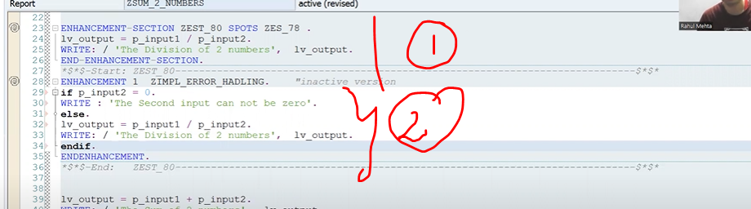

2-> Implementation code of enhancement section(Enhancement 1 – implementation).

**Enhancement Spot:**

It is a container for the enhancement point and section.

**User Exits:-**

Implemented as subroutine where we write our own code to enhance the application.

It is considered a modification and not an enhancement because we are changing the existing code

Since it is modification , we need to provide sap access key.

Available only in SAP SD module.

Syntax: perform userexit_userexitname.

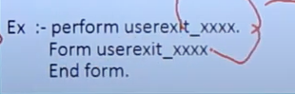

**Customer Exits:-**

* Implemented as Function Module -> Zinclude prog.
  + - Zinclude programs available inside the FM(Customer exists).
    - Used in all modules & also CE may not be created in all modules.
    - Enhancement. Enhance sap functionality in the customer namespace (client-specific custom developments and enhancements).
    - Not require access key.
    - Tcode – CMOD (create modifications) - to implement customer exits.
    - Tcode – SMOD (Search modification) – provide the list of cust.exits for the package of the prog.

**Types of CE:**

**Function Module Exits:**

**https://itsabaper.blogspot.com/2016/08/function-exit-or-customer-exit.html**

* FM exits -> With the help of FM, we can add our custom code to the SAP Prog.
* To find the FM/customer exit name in se38 program -> CALL Customer-Function ‘three digit number(000-999).( to navigate into the FM created in FM exit).(To get FM )->**se38**.
* FM name in Customer exit -> Exit_<program name>_<number>/xxx_<prog name>_<(000-999)>-> **se37**.
* These are created for **specific programs, screens, and menus** within the standard applications. Implemented as Function Modules. Inside this FM -> zinclude prog will be there.
* When click on FM syntax, it will navigate to the some FM – have zinclude prog - in that zinclude we will write our custom/own code to enhance the sap prog.
* Check each FM exit importing or exporting parameter to add our code based on the req .
* FM exit will be the part of menu exit & screen exit.

Way to find FM exit:

* Debug the sap std prog by putting the breakpoint at the **CALL Customer** function ‘xxx’ and chk each FM exit importing or exporting parameter to add our code based on the req
* Go to **SMOD tcode** and give the package name of the sap std prog(prog related to Tcode we need to enhance)(se93 tcode or prog->utilities->attributes/obj.directory.entry)
* Go to **Se84**(enhancements – customer exits) – provide the list of available customer exit for the part.sap std tcode/prog by passing its package name.

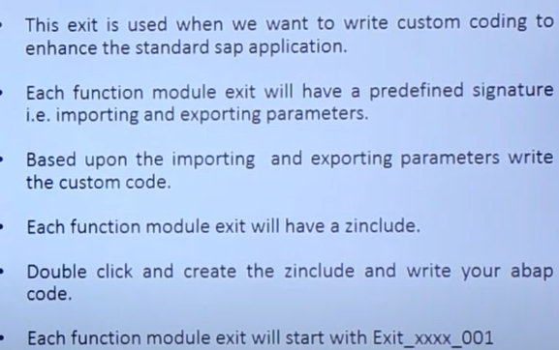

Once FM exit is done, we need to activate the FM as well as the Implementation in CMOD tcode.

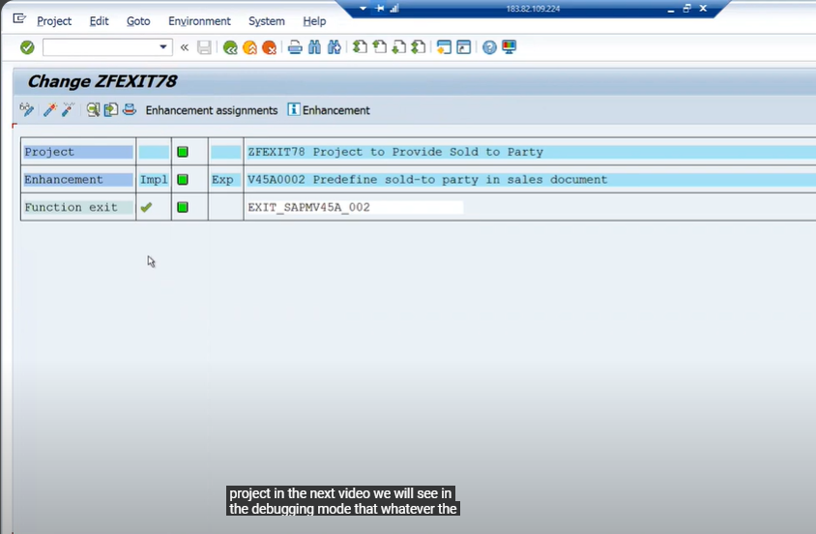

* Menu exit:
  + Add custom menu items to the sap std menu bar(Edit,goto…) of any sap prog.
  + 
  + Menu exist will have func.code starts with ‘+’ sign.Double click on ‘+’ , we will create custom menu.
  + Each menu exit will FM(have zinclude prog) to write the abap logic code for the custom menu.
  + We can perform customer specific functionalities on **these** menu items using FM in menu exit.

Ways to find Menu exit:

* Check for menu items starting with"+" (a plus sign) in the menu bar. (System-Status-GUI status-Menu Bar).
* Pass the package name of the program in **SMOD** transaction code. (se93 tcode or prog->utilities->attributes/obj.directory.entry)– click on Customer functions Menu exit.
* Pass the package name of the program in **SE84** transaction code.(Enhancements-Customer Exits-Enhancements-Package – Customer functions) - click on Customer functions Menu exit.

To implement some logic inside the custom menu items, we will use the function module exit appear for the part.customer exits.

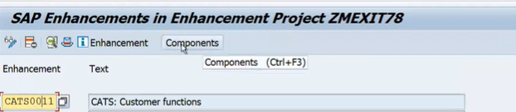

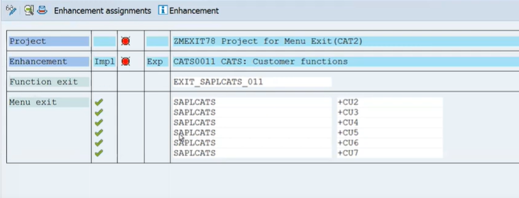

* Screen exit:

It allows the user to add custom fields to a screen in the SAP program via customer sub-screen which is called within standard screen’s flow logic.

Not adding the custom field in the sap standard screen , it is added to the customer created sub-screen & called from std screen.

When creating subscreen in cmod tcode , choose the screen type as subscreen.

Each subscreen(PBO & PAI) may have FM exit to write logic for custom screen.

Syntax : Call Customer-subscreen Sunscreen name including report name subscreen number.

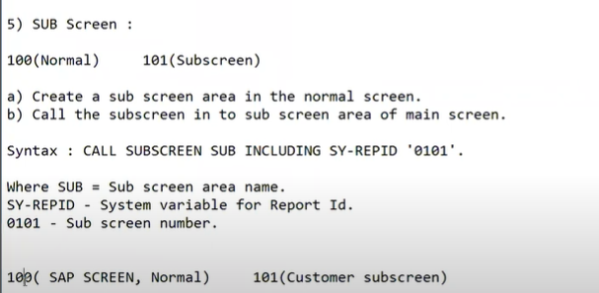

Way to find Screen-exit:

* + - Check in the screen flow logic of a std prog(tcode) for the statement **CALL CUSTOMER**-SUBSCREEN.
    - Pass the package name of the program in **SMOD** transaction code. Then click on the subscreen on the initial screen – screen exit(cust.exit).
    - Pass the package name**(se93 tcode -> input tcode name->display->pkg name will come**.) of the program in **SE84** transaction code.(Enhancements-Customer Exits-Enhancements-Package). Then click on the subscreen on the initial screen - screen exit(cust.exit).

Project for Cust.exit:

Project(grp of enhancement) must be created to implement the enhancements(grp of exits).

Proj -> Enhancement name ->exits.

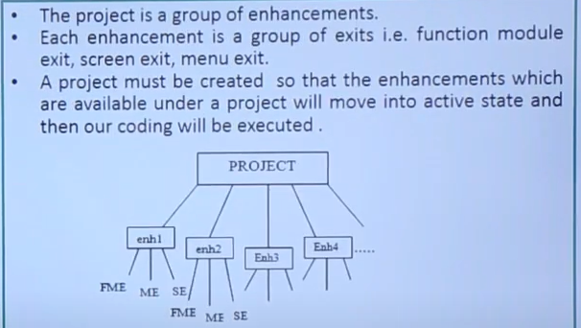

**Way to find exit:**

1.Using call customer function in se38.

2.Using SMOD tcode.

Way to find pkg name –>

1. se93 tcode -> input tcode name->display->pkg name will come or
2. Program -> goto -> Object directory entry / Attributes.

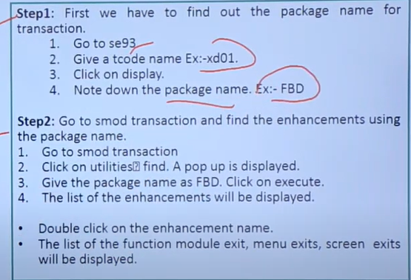

3.Using se84 tcode.

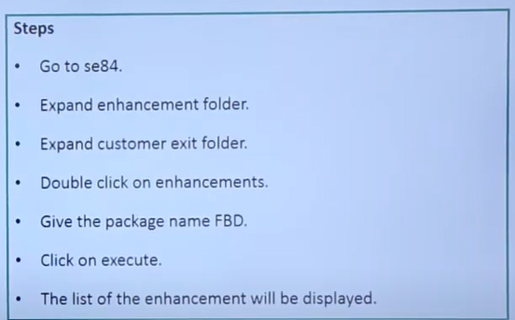

Imp.notes:

* One cust.exit can be assigned to the only one project at a time. Same can’t be used in another project which is already in used.
* SMOD - Transaction code to find a customer exit.
* CMOD - Transaction code to implement a customer exit.
* MODSAP - Table to find a customer exit .
* 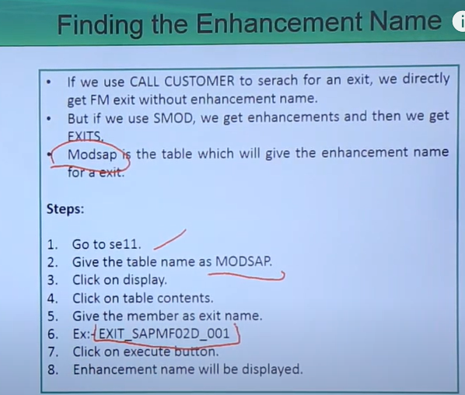
* MODACT - Table to find a project for a customer exit.

**BADI (Business Add-Ins):**

https://medium.com/@ruchirani88099/how-to-find-badi-in-sap-abap-dd973937309d

* Enhancements.
* A BADI is an enhancement technique that facilitates a SAP programmer, a user, or a specific industry to add some additional code to the existing program in SAP system.
* A BADI must first be defined and then implemented to enhance SAP application. While defining a BADI, an interface is created. BADI is implemented by this interface, which in turn is implemented by one or more adaptor classes.
* It is based on OOPS Concept (Interfaces & Classes).
* Interface - > define a set of methods, variables etc a class can use this method – never write any logic inside the interface. **An interface is a blueprint or a contract that defines a set of methods that a class must implement.**
* **Class**-> writing logic – Implementation can be done.
* **Multiple implementations can be done for a single badi definition.**
* SE18 – Badi definition-> Interface (Define the BADI with the interfaces where u can define the method name). **Syntax : IF_EX_<Badi_def_name>.**
* SE19 – Badi implementation -> Classes. (Implement the interface of BADI definition). **Syntax : ZCL_EX_<Implementation_name>.** Here, we can create new BADI implementation or use the existing BADI implementation.
* Need to find out -> Which method in the interface to be used for the requirement

Then what are method parameters needed.

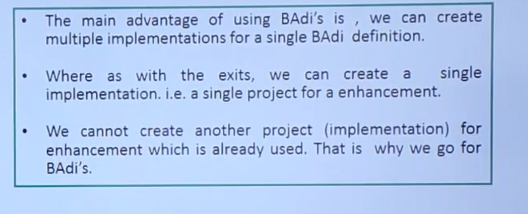

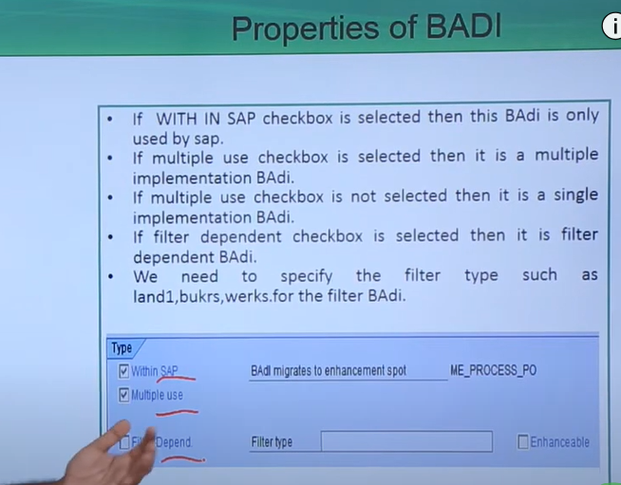

Enhancement Spot:

* + Consists of different BADI definiition. It is a container of BADI’s.
  + 1 - n relationship.(1 Enh.spot consists of n no of BADI).

Ways to find BADI:

1.Using the class CL_EXITHANDLER.

* SAP class - **CL_EXITHANDLER**.
  + In this class we have the method name - **GET_INSTANCE**. Inside this method, put a breakpoint on the method called **‘get_class_name_by_interface’**.Exit name will be BADI definition name.
  + Enter the req.t-code and it will stop into the class breakpoint.

2.Using SE84 tcode.

BADI Types:

Classic Badi.

New Badi(Kernal Badi).

Classic Badi:

* We can use SAP class - CL_EXITHANDLER. In this class we have the method name - GET_INSTANCE.
* Put a breakpoint in the method of a class **CL_EXITHANDLER** which will provide us all BADI definitions available in the system and pick which definition/interface will be useful for our requirement. Enter the t-code and it will pass into the class breakpoint.
* SE84 t-code, pass the package name to find all the BADI definitions.

Classic Badi Properties:

* **Sap Internal** -> Only it is used within SAP, will not allow any custom code/logic to be added. Customer will not allow to use this BADI
* **Multiple use** -> **(Multiple implementation BADI) ->** Can have more than one implementation for a Badi definition. In this case, all the implementation will be executed & can’t control the sequence of multiple implementation execution.All the implementation will be active.

(**Single implementation BADI**)->If not, single implementations(Single class) for a single badi definition.Can have multiple implementations but only 1 implementations to be in active .

* **Filter dependent** -> Badi implementation will be triggered only when it satisfy the filter value mentioned in the BADI implementation.
  + Remaining implementation will not be executed.

Kernal Badi:

* Mulitple use
* Can be implemented internally by SAP -> no custom development.
* Limited Filter Badi.
* AMDP Badi -> For especially to enhance the std.AMDP procedure.

—---------------------------------------

**BAPI extension:**

Extending a BAPI (Business Application Programming Interface) in SAP involves enhancing its functionality to accommodate custom business requirements that are not provided by the standard BAPI. This process typically includes creating custom fields and logic to extend the existing BAPI functionality. Below are the general steps and an example to illustrate how to extend a BAPI in SAP.

**Steps to Extend a BAPI**

1. **Identify the BAPI to Extend**: Determine which BAPI needs to be extended based on your business requirements.
2. **Enhance Data Dictionary Objects**: Add custom fields to the relevant structures or tables used by the BAPI.
3. **Enhance BAPI Structures**: Extend the BAPI structures to include the custom fields.
4. **Implement BAPI Enhancements**: Add custom logic in the BAPI implementation to handle the extended fields.
5. **Test the Enhanced BAPI**: Thoroughly test the extended BAPI to ensure it works as expected with the new fields and logic.

Module Pool Programming:

Collection of screens, flow logics , gui menu bar and abap code to build an application.

**Forms:**

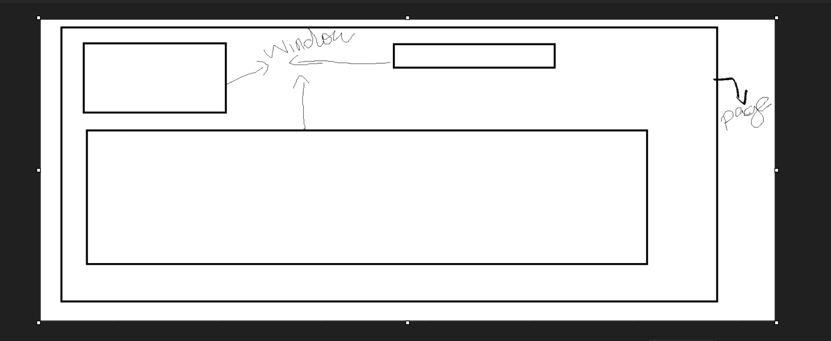

**FORM LAYOUT**

**SAP Scripts: (se71)**

Tool used to build and manage the preformatted business forms by designing the layout(structure of the document) of the Business printing docs such as invoice, del.notes etc.

Key Components of SAP Scripts

* Layout Set – Defines the structure of the document (e.g., header, main window, footer).
* Standard Texts – Reusable text elements that can be included in multiple scripts.
* Symbols (Variables) – Used as a placeholder to display dynamic values in the document.
* *Driver Program – An ABAP program that fetches data and passes it to the script.*
* *Print Program – Controls the flow of data and calls the SAP Script.*

Layout component:

* Pages – Multiple pages will support in forms for a business documents.Define different sections of a docs.
* Window – Page information are divided in the form of windows such as name window , address window, contact window. Defined area on the pages where the content will be displayed. Each window have different data.

**Types:**

Main window -> Continuous window can extent the page if the current windows is fills up.

Variable window -> This window can have the variable contents displayed on them. The contents of the window cannot exceed the window size

Constant window -> The constant window can have a fixed content and is formatted only once.

Common windows:

* 1. **Header** – Displays document title or company logo.
  2. **Main Window** – Holds the dynamic text and table content.
  3. **Footer** – Contains totals, page numbers, or signatures.
* Page Window – Assign window to a specific page. Defines the position and size of the window on the page.
* Text format (Paragraph & Character format) – Formatting the text and entire block text such font size ,style , alignment.

We can add logo in the scripts by uploading the img in the tcode se78 and display it in script using BITMAP.

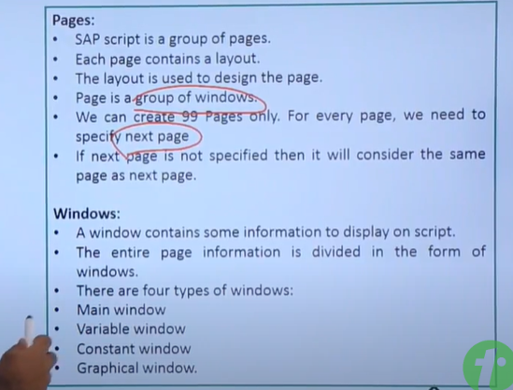

**Standard Texts and Graphics:**

* Standard Texts for your report can be created using transaction **SO10**
* Graphics and printer macros are uploaded with [report](https://www.guru99.com/all-about-abap-report-programming.html) RSTXLDMC into individual standard text documents or through transaction **SE78.**Graphics are uploaded in “Baseline TIFF 6.0” format (.tif files on PC)
* SAP Script & Standard text elements can exported or imported between two systems using **RSTXSCRP** program

Client dependent.

1. **SAP Scripts – Client-Dependent**

* Stored in tables: SAP Scripts are stored in client-specific tables (STXH, STXL), meaning they exist only in the c lient where they were created.
* Each client has a separate copy: If you create an SAP Script in Client 100, it won’t be available in Client 200 unless you transport it.

2. SmartForms – Client-Independent

* SmartForms are stored as generated function modules in the Function Builder (table: STXFADM), which is client-independent.
* Since function modules are stored at the system level they are available across all clients.
* Any changes made to a SmartForm reflect in all clients without needing a transport between clients.

**Key Differences:**

| **Feature** | **SAP Scripts (Client-Dependent)** | **SmartForms (Client-Independent)** |
| --- | --- | --- |
| Storage | Stored in **STXH/STXL** (Text Tables, client-specific) | Stored as **Function Modules** (client-independent) |
| Availability | Exists only in the client where created | Available across all clients |
| Transport | Requires transport for each client | No need to transport between clients |

How do you **call an SAP Script** in an ABAP program?

CALL FUNCTION '**OPEN_FORM'** EXPORTING FORM = 'Z_MY_SCRIPT'.

CALL FUNCTION **'WRITE_FORM'** EXPORTING ELEMENT = 'MAIN'.

CALL FUNCTION **'CLOSE_FORM'.**

**RSTXDBUG - debug the sap scripts**

**SMARTFORMS:**

<https://www.saphub.com/smartforms/sap-smartforms-old-transports/>

<https://community.sap.com/t5/application-development-discussions/how-to-call-smartform-by-a-report-program/m-p/9582223>.

Smart forms – Tool to design layout of printing form/docs. Every smartform on execution generates a function module.

The transaction code to create a smartform is Smartforms.

Components of Smartforms:

Global Settings:

* Forms Attributes – Generic information about the smartform like date, time, package etc.
* Form Interface - The purpose of form interface is to **pass input and output parameters.**
  + Input
  + Output
  + Tables
  + Exception
* Global definitions – Whatever we do/write here, it can be accessed globally throughout the smartform.
  + Global data – declare a var,workarea and internal table – data declarations.
  + Types – Create structures using types statement (code).
  + Field symbols - Declare field symbols(pointers).
  + Intialization – proficient to write logic.
  + Form routine – create subroutines.(perform..)
  + Currency/Quantity field – we use whenever we have currency or quantity fields.

Pages & Windows:

* + Page is available – inside this page – default main window will be there/present in a page(Main window).

Window types:

* + **Main Window**: It is used for the continuous output such as table output - based on data volume generate the next pages to print the text - only 1 main window per Smartform. If there is more than 1 main window , it gives us a run time error.
* **Secondary Window**: It is used for output with a fixed length - multiple sec.window can be there - can’t flow to next page.
* **Copy Window:** It is also a kind of special secondary window which is used for making pages as copy or original - no of copies >1 execute.
* **Final Window:** It is a kind of special secondary window used for details which are needed to be processed/executed only at the end of each processing form/page- **completes the design/processed every pages in SF and triggers the final window for each pages again.**

**Design properties:**

**Conditions -** Control whether a node (text, window, folder, etc.) is executed - based on **single condition -** display or do something

**Additional events -** Used in the Main Window to print headers/footers or handle page breaks - like events such as only on main windows etc..

**Alternative -** Works like an IF-ELSEIF-ELSE logic - based on **multiple conditions -** check or do something.

**Command -** Specific instruction or action to be executed.In Smart Forms: A Command node is used to:  
 trigger a page break , Start a new page , Call another smart form

**Folder -**logical container used to group multiple nodes and page protection can be done - Group item details by one condition - page protection enabled inside the main window only.

Folder(page protection) : This is used to print the continuous text without any page break.

**Page protection can be done using folder as well as smartstyle.**

Events:

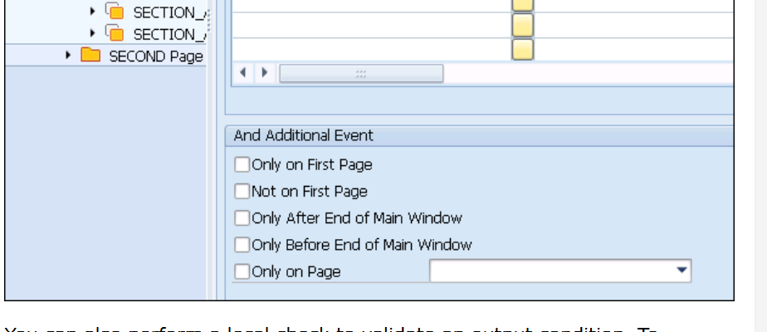

* Create window by right clicking on page or through form painter.
* Template is used for static data -> fixed no of rows & cols in the window.

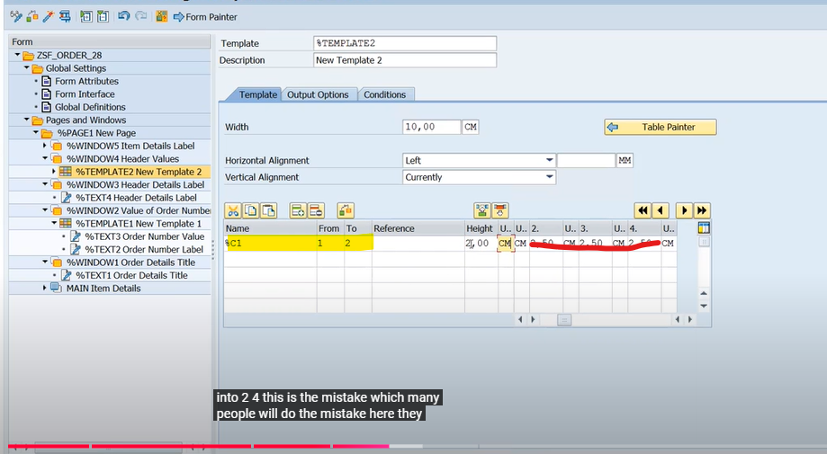

Yellow ->mention the no of rows we req – from to –(From row 1 To row n) – n may be 1 or more 1)

If from -1 & to -1 -> only 1 row is required.

* Table is used for dyamnic data display ->Rows & cols not fixed. Elements inside the Table
  + Header -> Display field labels.
  + Main Area -> Display data values.
  + Footer -> Display information on the footer like sum , amt total.
* • A **template** is like a table printed on paper for visual representation, where you can't add or remove rows dynamically.
* • A **table** in SAP is like an Excel spreadsheet where you can dynamically store and manipulate rows and columns of data.
* We will call the smartform in the prog through the FM of the smartform.
* Call **‘SSF_FUNCTION_MODULE_NAME’**- FM to get the FM name of created smart form. Then use the retrieved FM to get the formatted documents.

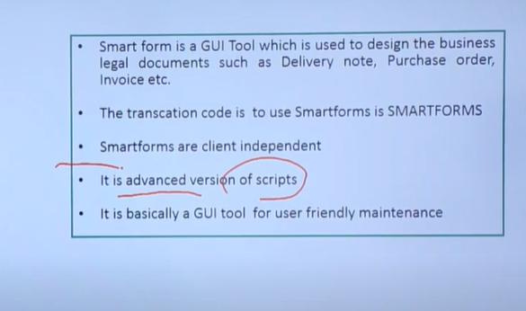

SmartStyles: (Tcode - smartstyles)

Smart Styles are used to define the formatting of text and fields within Smart Forms and it can be reusable too. Default ya paragraph format need to be created.

For eg :

* Font size and type
* Bold / Italic / Underline
* Paragraph alignment (left, center, right).
* Indentation and line spacing
* Barcode creation.

Paragraph format:(format the whole para).

Indents , spacing , text flow-page protection , font

Character format:(format of single letter/word - rarely used)

Superscript & subscript , barcode , font.

Header data:(mandatory - assign atleast one paragraph format)

Standard settings - default format for the paragraph - whenever

The default value of a smart style is maintained in the header data. The smartform can use the values assigned to the character or paragraph format of the smartstyle , if it is not assigned with any values,smartforms uses default value(header data) of the smartstyles.

<https://easyabapforbeginners.wordpress.com/2018/02/22/sapscript-ii-logo-header/>

SCC1 tcode – used to transport the tr within the same server of different clients

SAP ABAP question:

https://www.sapignite.com/sap-abap-interview-questions-and-answers/.